An Englishwoman’s Loose Gown c1610

Unfitted gowns, cut without a waist seam to fall directly from the shoulders, formed a popular outer garment for women from the mid-16th to early 17th century through most of Europe- compare the Spanish ropa, Italian zimarra, German rapan, and English loose gown. Such gowns could be made in a variety of fabrics and styles and were worn primarily by the middle and upper classes. While this gown is not directly based on a particular extant garment or painting, it was heavily inspired by them, as well as by the patterns given in tailoring manuals from the period. It is intended for a prosperous middle-class wife or daughter, or potentially a member of the lower nobility, since while it is made of a fair amount of wool with velvet trim, it is not the more expensive silk or velvet preferred by those who could afford it.

I heavily drew on the garments presented in Patterns of Fashion 3: the cut and construction of clothes for men and women c1560-1620, by Janet Arnold, for my gown. The main pattern, drafted by Mistress Melisant, comes from the floral gown on page 118, altered to close in the front, as on page 98. The gown on page 98 also displays the loop button closure and grouped buttons used here. The plain collar is seen on page 111. The sleeves are patterned after the round sleeves given in figure 41, a loose gown pattern diagram from Juan de Alcega’s 1559 Libro de Geometria, pratica y traça. Such sleeves appear in portraiture for the next 50 years. Buttons similar to mine can be seen in various portraits and on extant garments, such as a fencing doublet on display at the Met.

Materials:

- 5 yds midweight brown wool coating (body)
- ½ yd heavy linen canvas (interlining)
- ½ yd turquoise herringbone silk (lining)
- ¾ yd brown medium weight brown linen (facing)
- 7 yds brown rayon velvet ribbon, ⅞ in (trim)
- Unbleached linen thread (waxed)
- Brown silk thread (sewing weight)
- Brown rayon thread (heavy weight)
- 9 wooden beads, ½ in

The gown is made of mid-weight wool coating with a herringbone silk lining, linen canvas interlining, and plain linen facing. The wool coating has comparable weight and drape to the extant velvet gowns, and fulled wool in different weights and qualities is well documented from the 14th century onward. While the lining is slightly unorthodox (I chose a material from my stash), contrast linings in matte, midweight fabrics, such as the yellow linen lining the gown from PoF pg 118, were in use. The linen interlining and facing correspond well to the materials used in the extant garments.

Structural seams were sewn with unbleached linen thread, while hems and the trim were sewn with brown silk thread. This follows the observed practice of sewing unseen or structural seams with heavy, then-inexpensive linen thread, saving the more expensive matching silk thread for visible seams. Heavy rayon buttonhole twist (I was unable to find silk twist locally) was used to cover wooden beads and as button loops. 7/8th in rayon velvet ribbon forms the trim (again, I was unable to find silk velvet ribbon. All available online had frayed, rather than woven, edges. Silk ribbon with selvedge edges was definitely available at this period, as seen on various garments, and velvet was popular for those who could afford it. By the 18th century, silk velvet ribbon with selvedge edges was also available, as seen on an extant hatband in the V&A. However, the few extant garments with velvet guards are trimmed with strips cut on the bias, then hemmed. I wanted to avoid a bulky turned hem, so I chose the available rayon ribbon, rather than the frayed silk ribbon or cutting fabric to width.)

The entire piece is hand sewn. The interlining is pad stitched to the lining and to the inner collar. A running back stitch was used for the primary seams with the edges whipped down. The same felling stitches were used to attach the trim and facing, while a tighter stitch was used to attach the sleeves to the body. Modified blanket stitches edge the tabbed wings. The buttons were constructed following the instructions on page 51 of The Tudor Tailor (Ninya Mikhaila and Jane Malcolm-Davies), and the button loops using a simple five bowe fingerloop braid, as detailed in Tak V Bowes Departed, Elizabeth Benn’s and Gina Barrett’s study of a 15th c braiding manual.

I’m incredibly happy with how this gown turned out. It was my largest sewing project to date and my first time working with heavy wool. To complete it, I needed to learn how to pad-stitch a collar, cover buttons, and fingerloop braid. While I wouldn’t recommend drafting and cutting sleeves out of your remaining fabric at midnight, this was a joy to work on, and I’m delighted to share it.
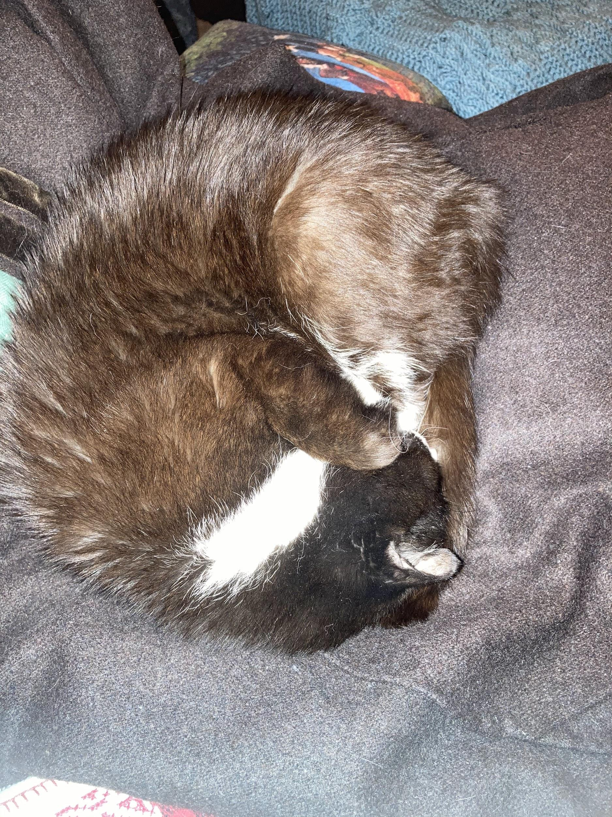
Sewing assistant, taking a hard-earned nap.
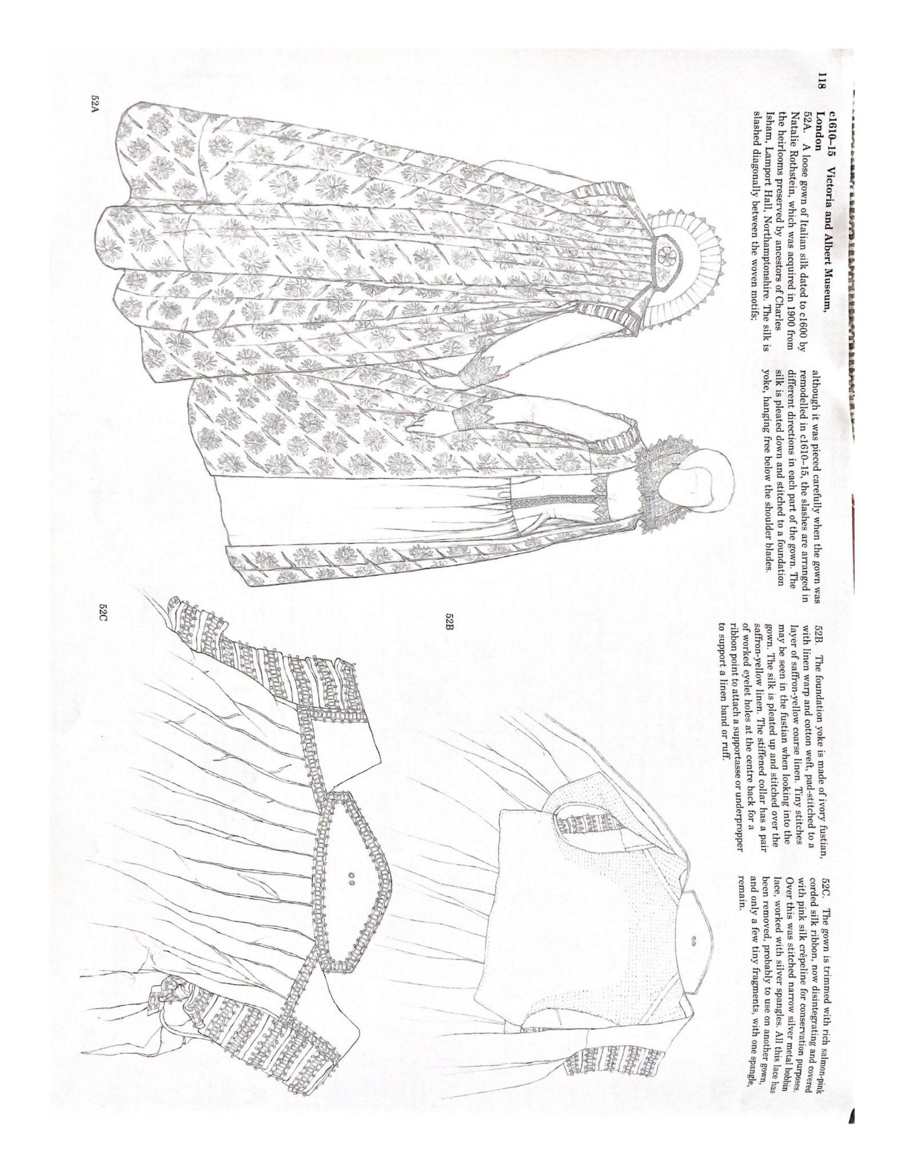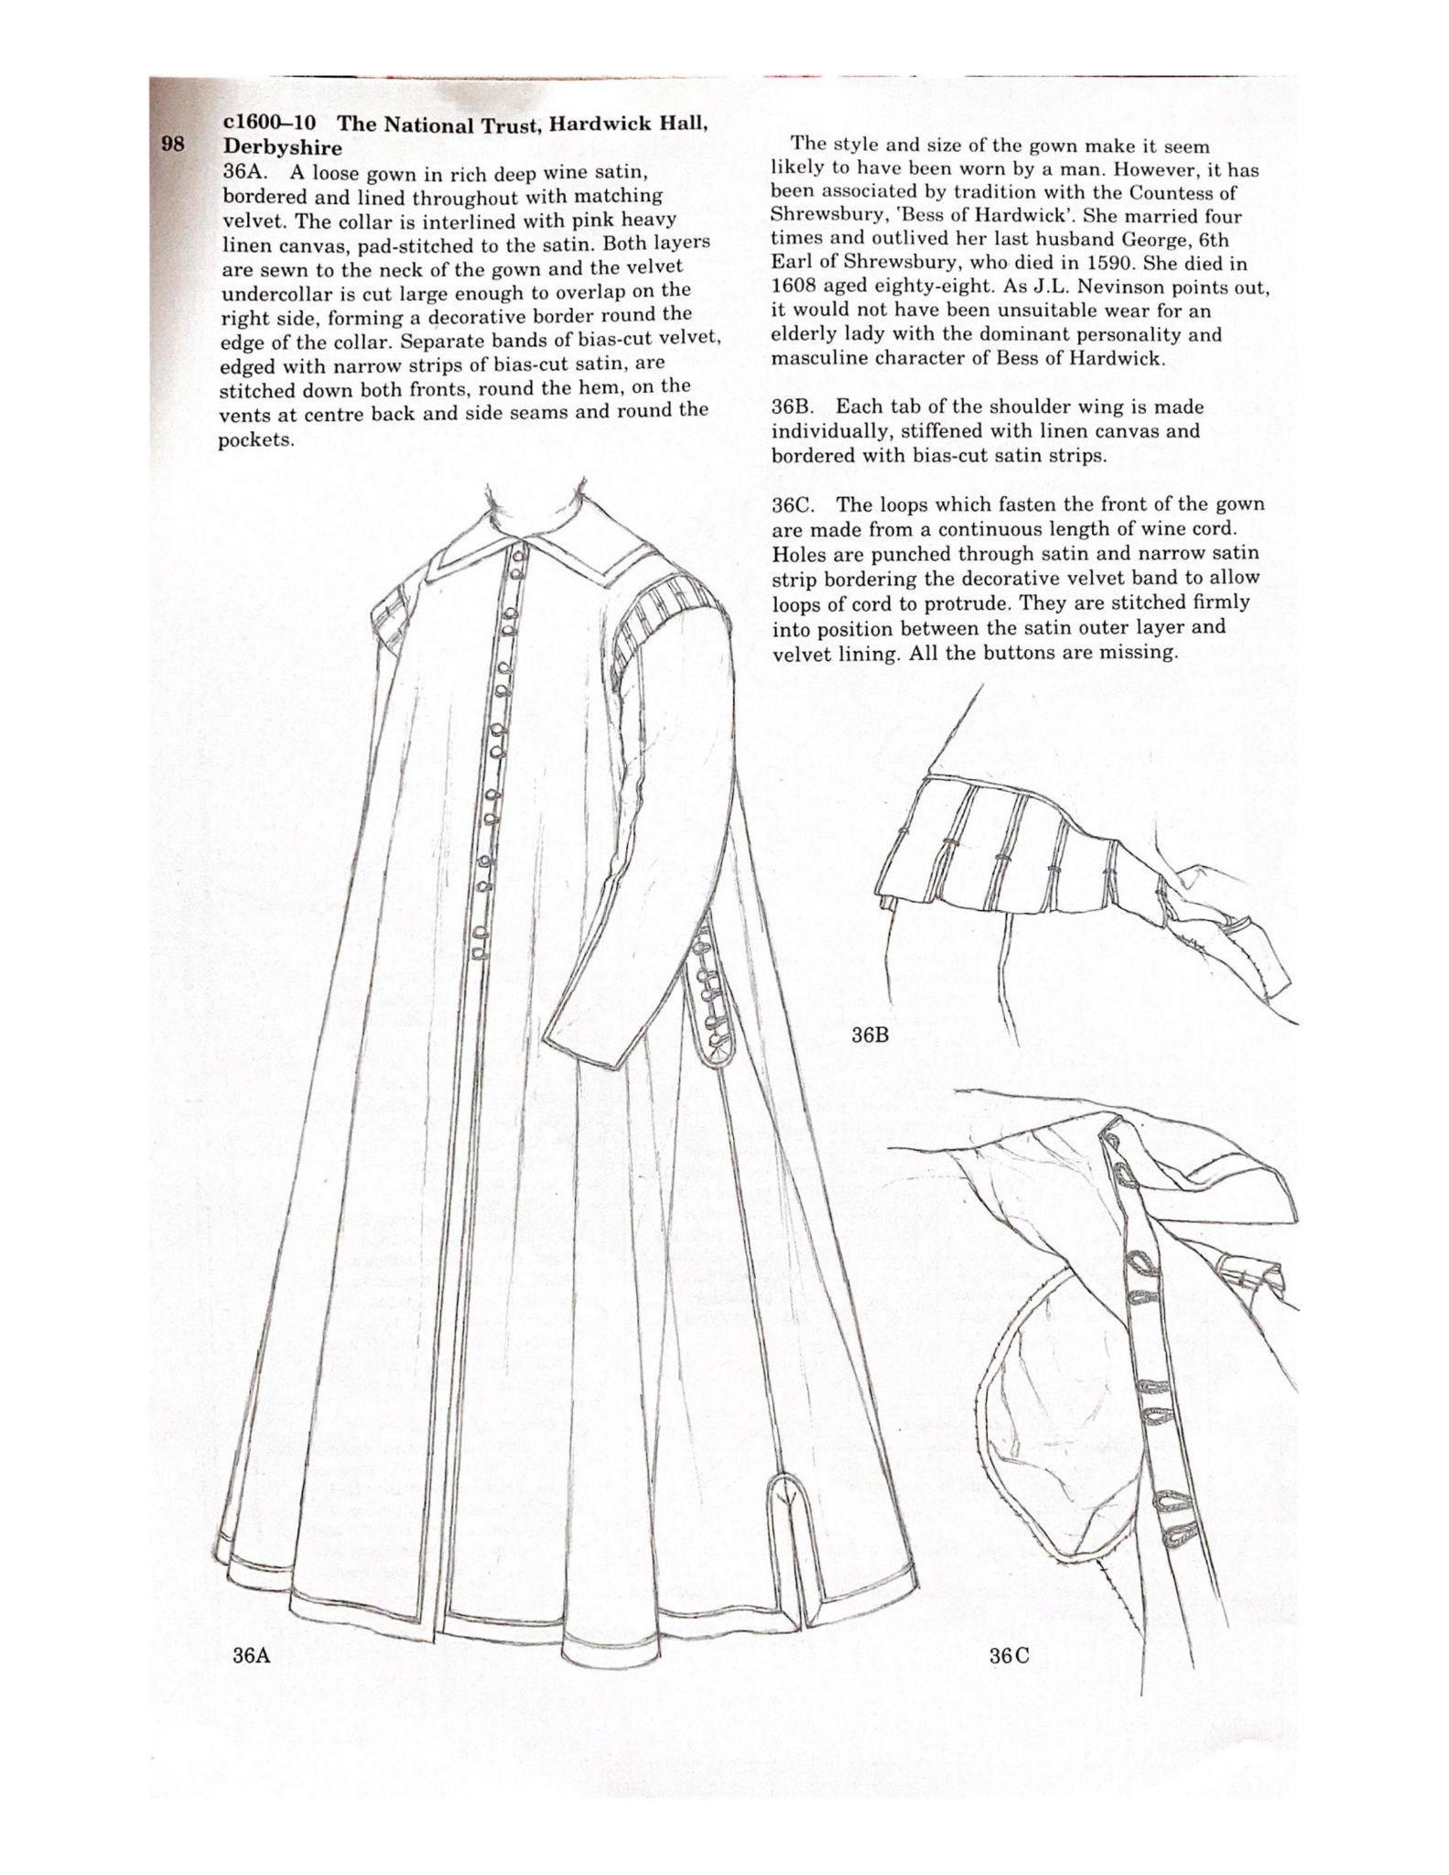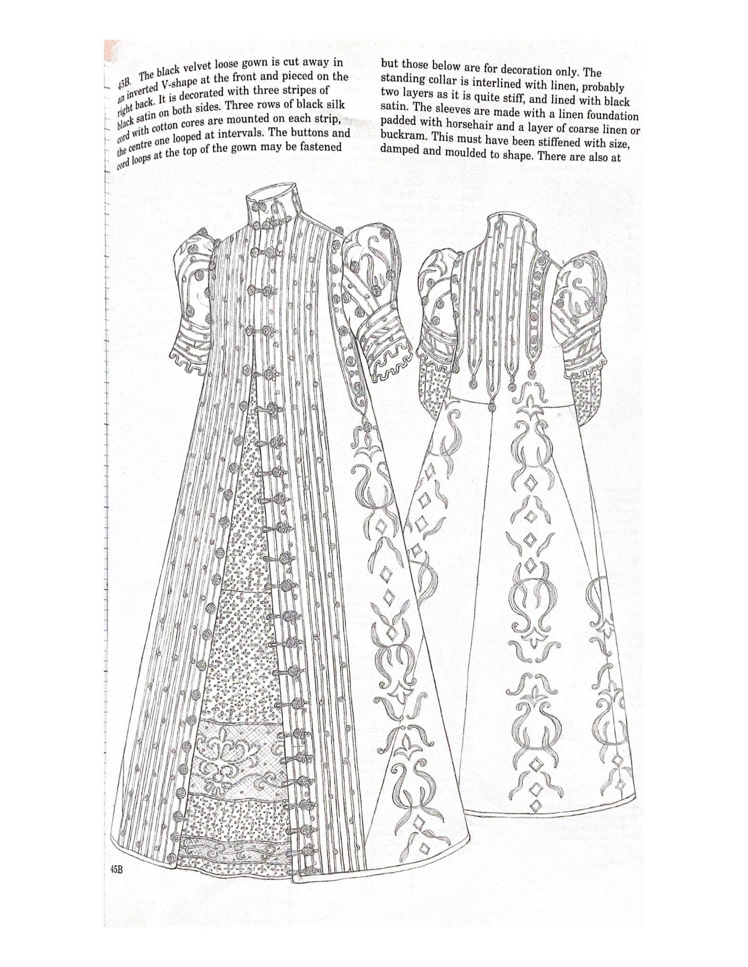
Loose gowns inspiring my own, from PoF 3.
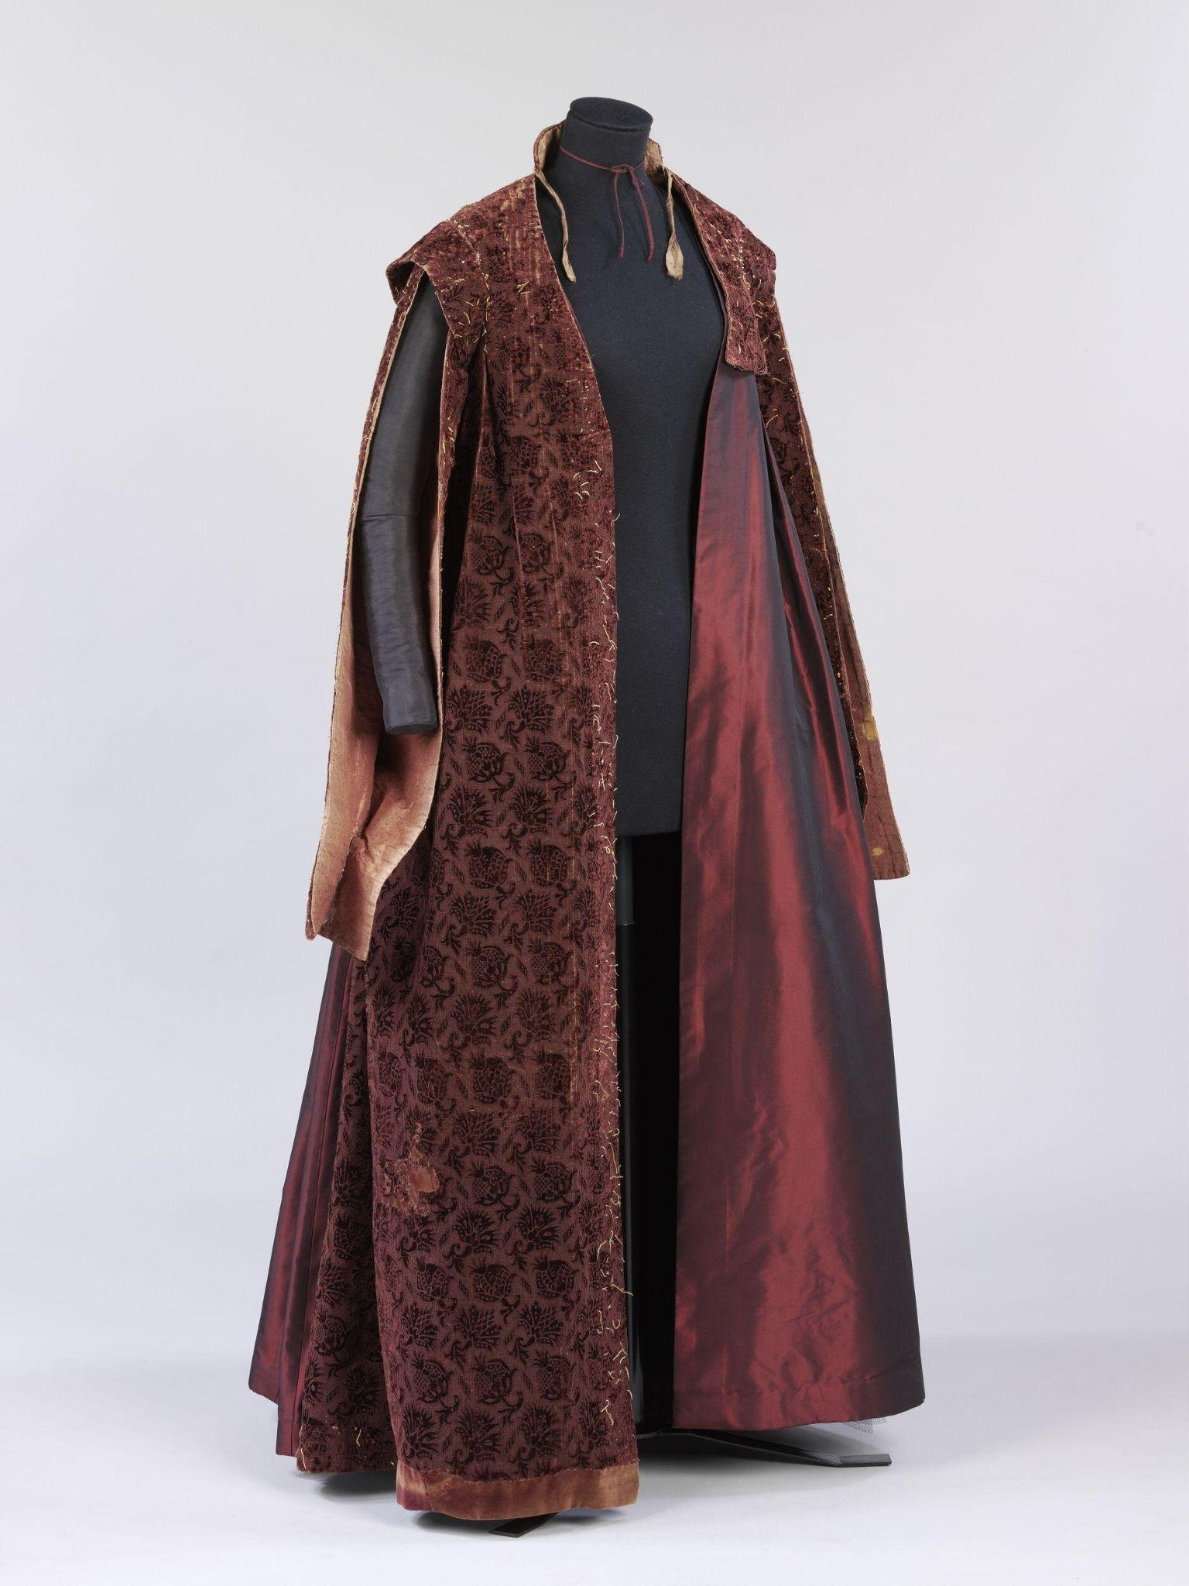
Mulberry velvet loose gown with round sleeves (Pof 3, pg 122). 1610-1620. Held at the V&A.
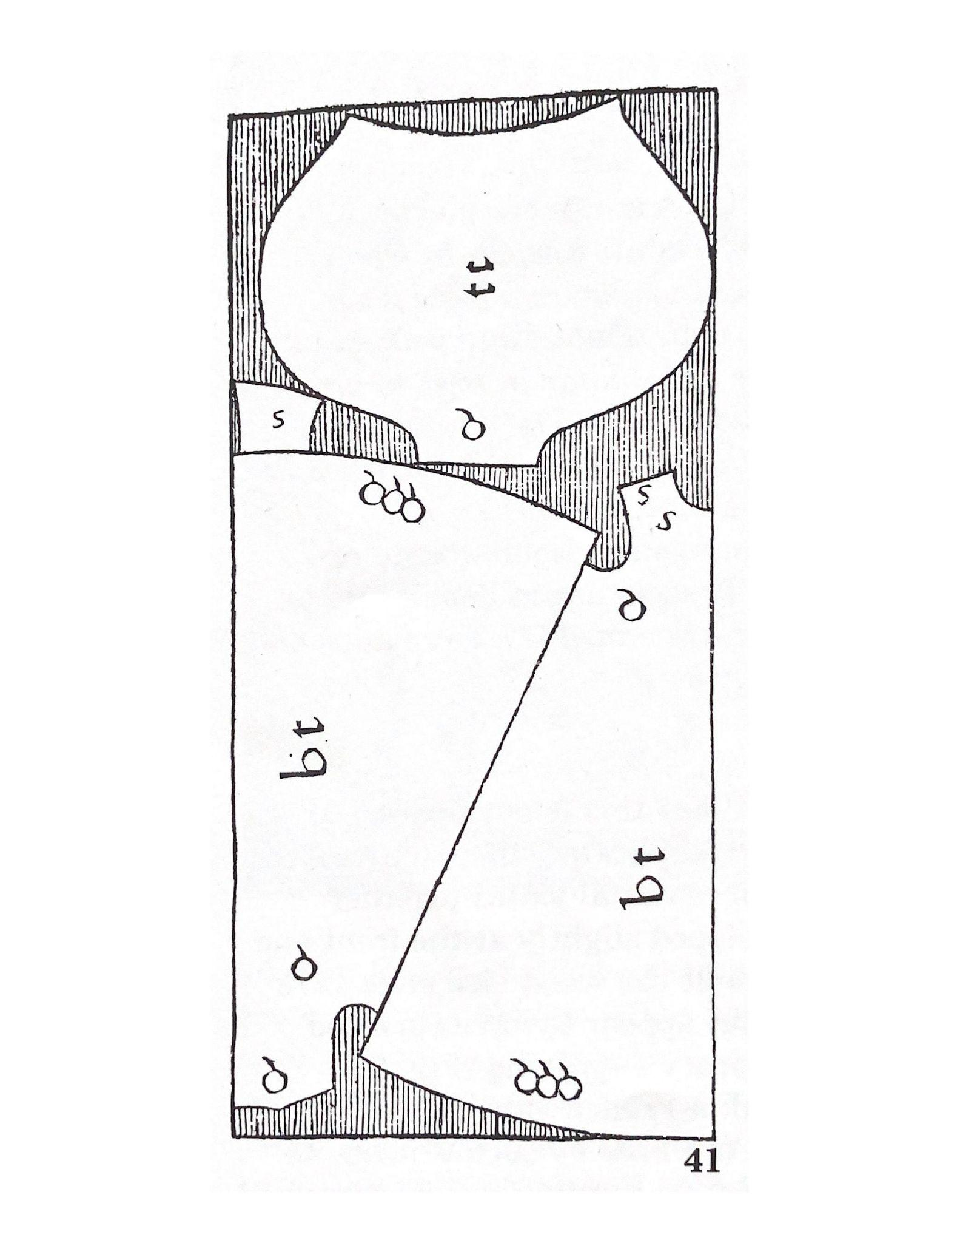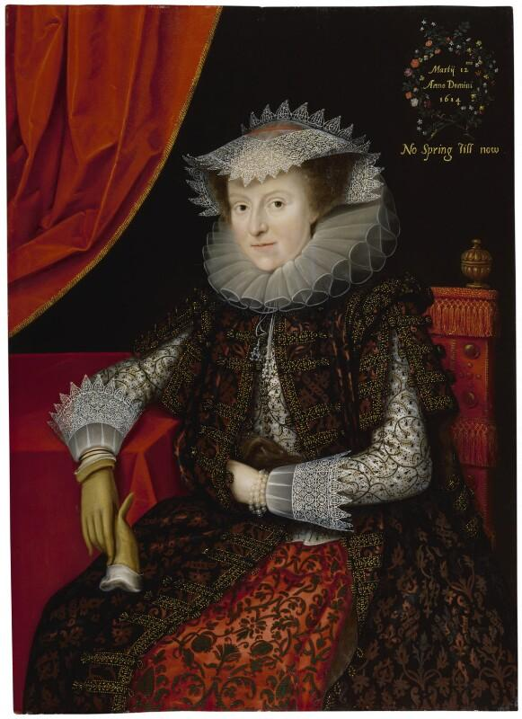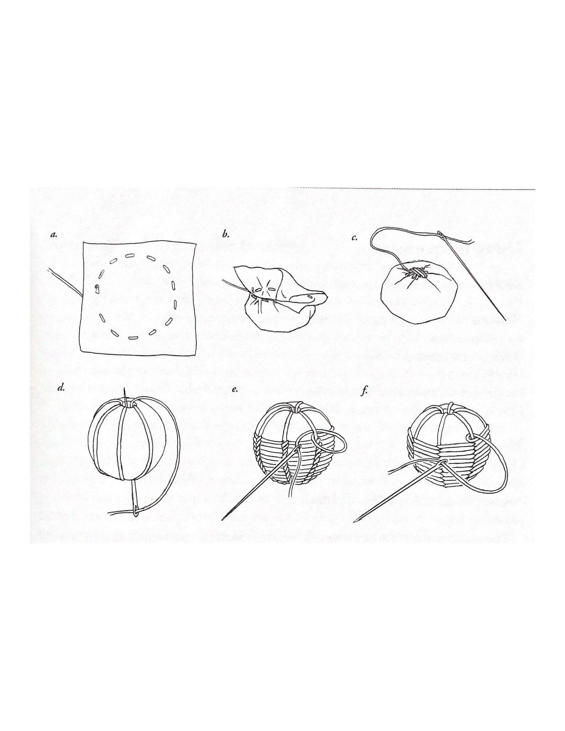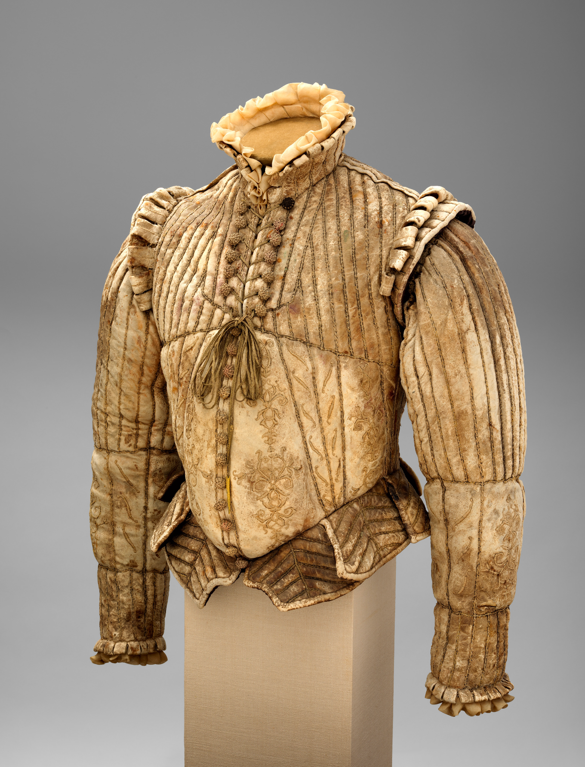
From top left: Alcega’s loose gown pattern diagram, Marcus Gheeraert the Younger’s 1615 portrait “Probably Mary (nee Throckmorton), Lady Scudamore”, The Tudor Tailor button diagram, and a detail of similar buttons on an extant doublet.

References:
Arnold, J. (1985). Patterns of fashion 1560-1620: The cut and construction of clothes for men and women c1560-1620. New York: M/Drama Book.

Barich, K., & McNealy, M. (2015). Drei schnittbucher: Three Austrian master tailor books of the 16th century.

Benns, E., Barrett, G., & British Library. (2019). Tak v bowes departed: A 15th century braiding manual examined.

Met Museum. (2022). Fencing Doublet. Arms and Armor. New York City, New York.

Mikhaila, N., Malcolm-Davies, J., Johnson, C., & Perry, M. (2006). The Tudor tailor: Reconstructing 16th-century dress. Hollywood, Calif: Costume and Fashion Press.

National Portrait Gallery. (2022). Probably Mary (nee Throckmorton), Lady Scudamore. Tudor and Jacobean Portraits Database. London, UK.

V&A Museum. (2022). Gown. Textiles and Fashion Collection. London, UK.

V&A Museum. (2022). Hat. Textiles and Fashion Collection. London, UK.

