Materials used: vegetable tanned calfskin (dyed black by the tannery), vegetable tanned goatskin (dyed white by the tannery), and golden yellow deerskin suede split, likely chrome-tan, dyed by the tannery. Also: white deerskin lace, sold to me precut, black waxed linen thread, various leatherworking tools (awls, punches, needles, mallets, scissors/knives), one brass buckle, entirely too many brass spots which were extraordinarily difficult to set without the correct tool. All supplies were purchased from Tandy Leather Factory.

Due to the nature of Golden Awl as an event for creating an object within a set time limit, I do not have many early pictures of the bag construction. What follows are the bag as I was completing it at a later date (8 hours having been somewhat insufficient to complete the purse) and after it was finished.

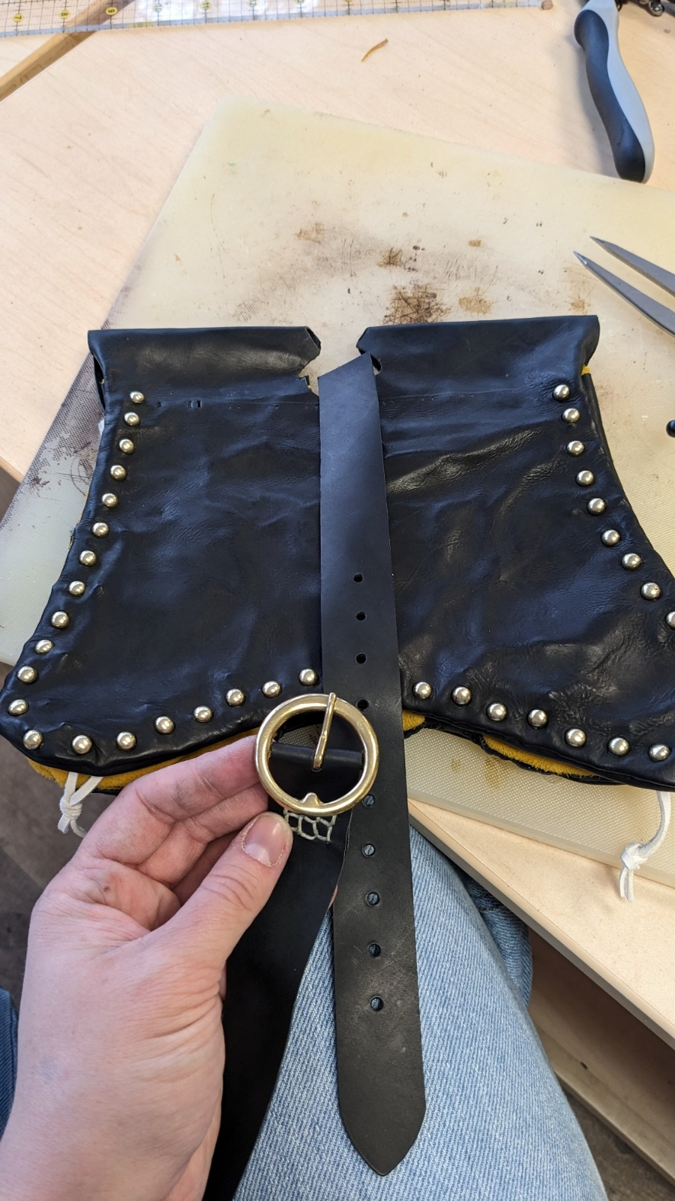(LEFT) Front flap prior to beginning the lacing that makes the channel for the belt.

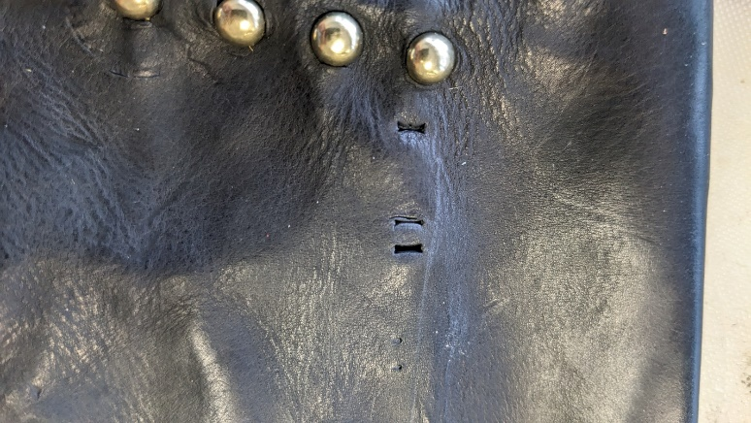(ABOVE) Measuring and making the lacing holes.

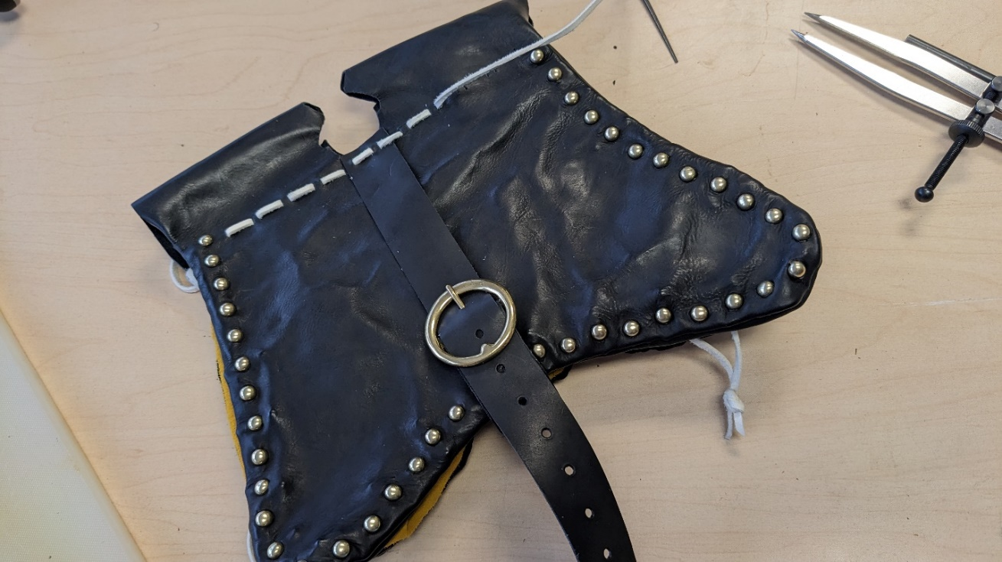(BELOW) Nearly finished with the lacing, the last step to completing the bag. For the lacing, I did a simple running stitch which was described in *Purses in Pieces* (Goubitz).

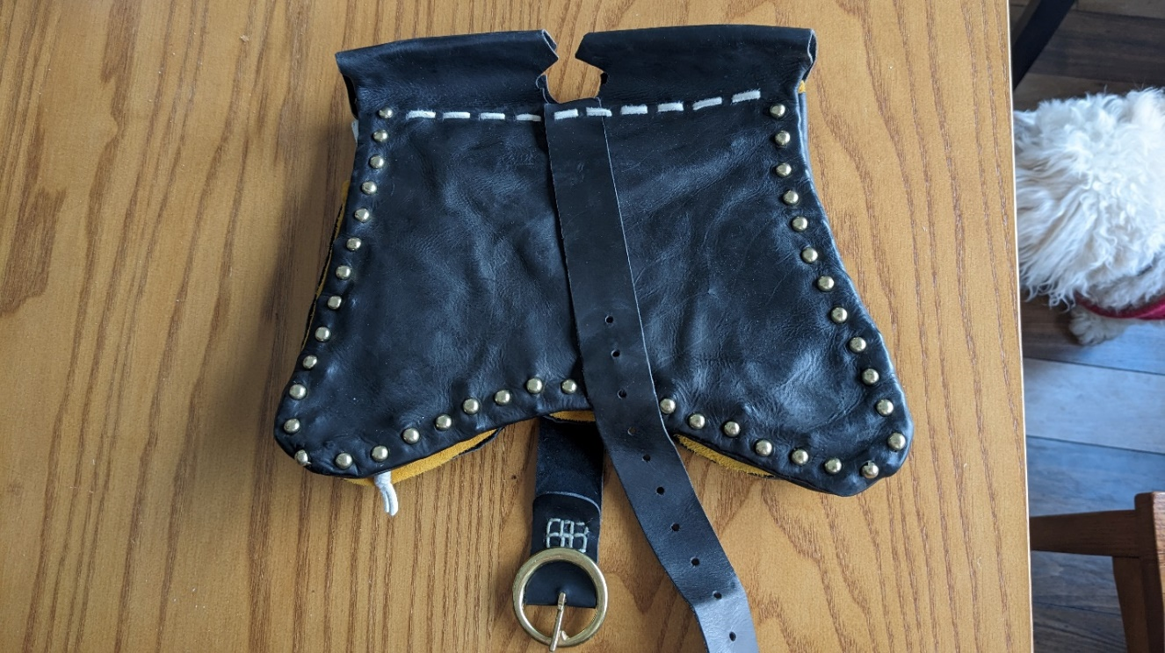

(RIGHT) Front of the bag post-completion, with the buckle strap open to show the stitching keeping the buckle in place. Most of the purse is saddle stitched, but I wanted several lines of stitching for the buckle reinforcement, so I did a grid of stitches instead.

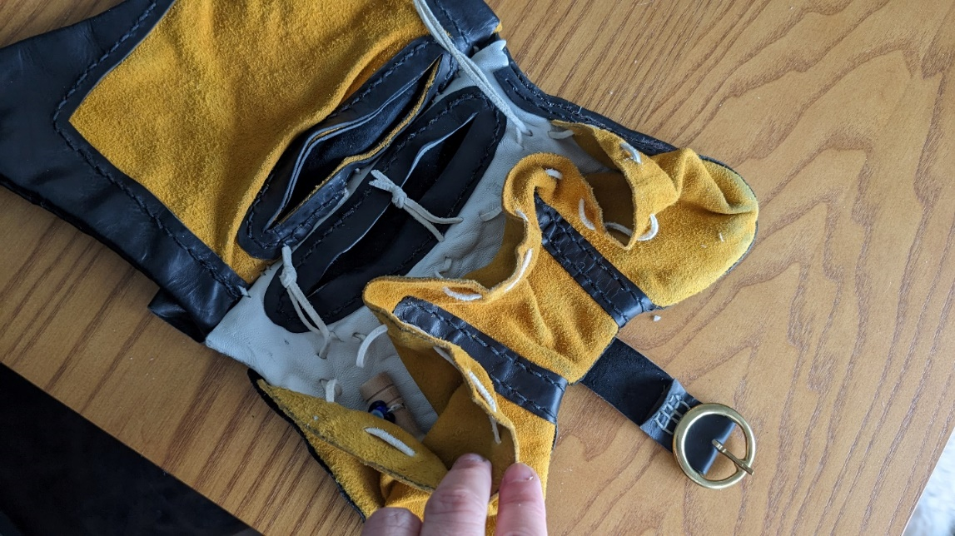(LEFT) Holding open one of the interior pouchlets to show the lacing pattern for these – the ends of the lace drawstring on each pouchlet might have had a bead stopper on extant examples. I simply knotted the ends together so they won’t be accidentally pulled through.

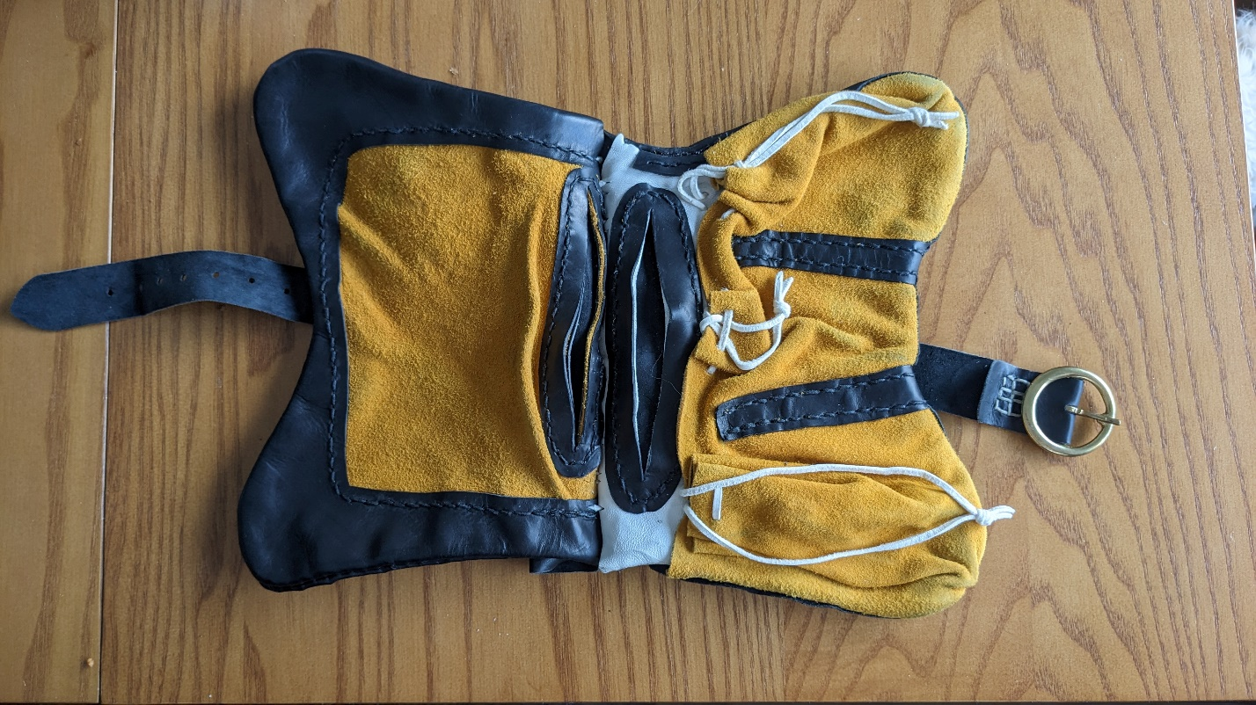(BELOW) The complete bag laid flat, pouchlets closed. The pouchlets and top flap pocket were made of a deerskin suede split – historically, fabric or even a chamois skin would have been used, but these are a reclusive, wild antelope native to the Alps, and their skins are a bit difficult/expensive to source in North America. Most fabrics degrade faster than leather, but the weave of the fabric has been detected from imprints pressed into some of the extant examples.

Though not particularly obvious or visible in the completed project, the pouchlets are stitched onto a white goatskin that makes up the front of the main pocket. The lacing was all precut white deerskin lace. Colors were chosen based on the Andelcrag baronial heraldry, as it is my intent for the complete purse to become part of the Andelcrag Bardic Champion regalia.

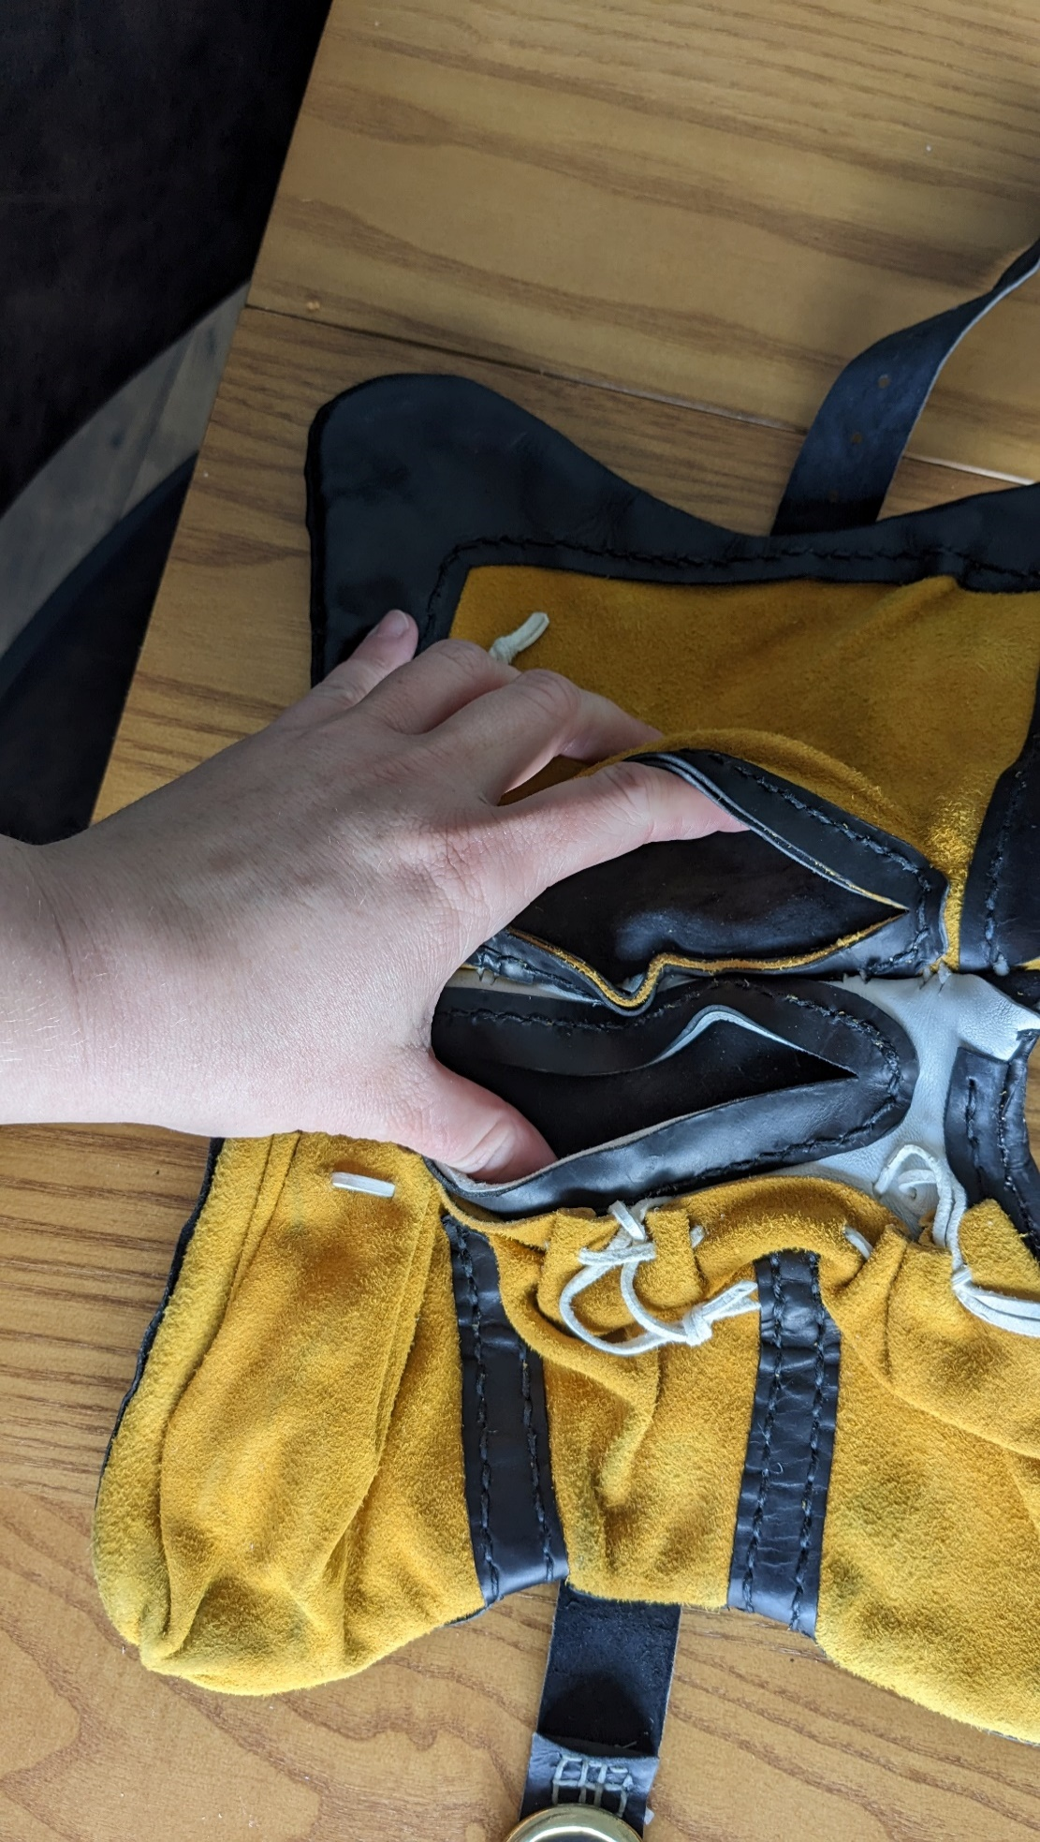(RIGHT) Holding open the flap pockets. The aperture is reinforced with another layer of calfskin (the same material used for the front and back flaps). The same calfskin is also used as reinforcement on the stitching of the pouchlets.