Intro to the Plucked Psaltery
Elizabetha de Picardia (Elizabeth Krause)
5/17/2021
- Historical Background
  - Popular in the middle ages. Comes in many different shapes. No surviving (Western) psalteries. Fell out of favor in the Renaissance due to lack of chromaticism.
  - Versions of this instrument are found all over the world.
  - Commonly called a lap harp in America today. Often used as an educational toy or folk instrument.
  - The bowed psaltery is a different instrument. It was invented in the 20th century and will NOT be covered in this class.
- What you need to start playing:
  - Psaltery
    - TK O’Brien carries high quality small instruments. I would recommend this as a great beginner instrument, but there are other good brands out there as well.
    - Many available second hand (ebay.com, ShopGoodWill.com). Make sure you weigh the total cost of a secondhand instrument before buying. Expect it to require new strings. There is also more of a gamble that the instrument will be damaged to the point of not being playable (slipping tuning pins or significant structural damage that will compromise the life of the instrument).
    - I highly recommend one with zither pins as opposed to other tuning options (screws/bolts/etc.). These are more reliable and often indicate a better instrument construction.
NOTE: If you find one with wooden tuning pins, make sure it is from a respectable maker and has been maintained well. Even well-made wooden tuning pins will be more difficult to tune than zither pins.
  - Tuning wrench
    - New instrument probably comes with one.
    - Look for a tuning wrench designed for autoharps, hammered dulcimers, or zither pins.
    - You can get either a square or star shaped wrench. Star shape is a bit easier to use, but usually more expensive. It is not required.
    - Do not get a tuning wrench designed for pianos or harps. These will most likely be a different size and not fit your instrument.
    - DO NOT TUNE YOUR INSTRUMENT WITH PLIERS!!!

  - Tuner
    - Can download a tuning app on your phone for free.
    - Clip-on tuners can be difficult to use since there isn’t a good place to clip them.
    - If you have a Snark brand clip tuner, you can pop off the head, put sticky tack on the base, and stick it to one of your tuning pins. This makes an effective connection.
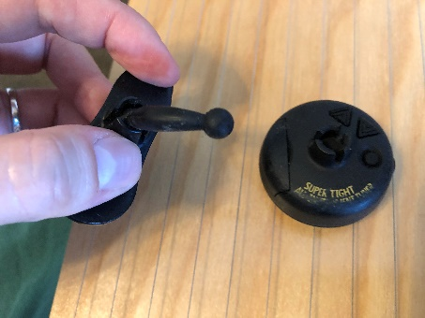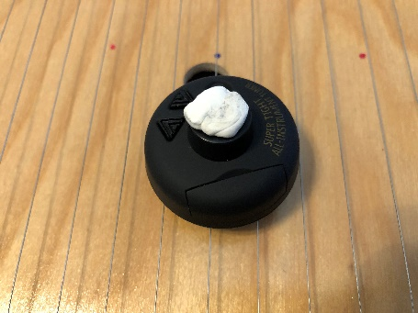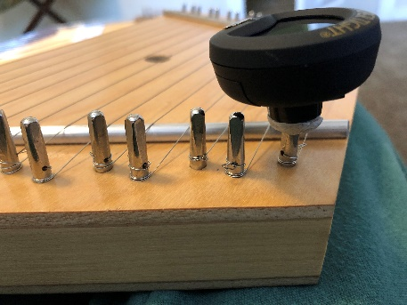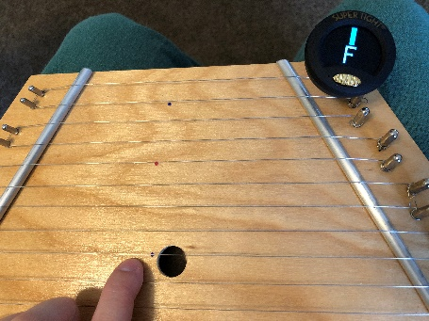
  - Case (recommended, not required)
    - Will extend the life of your instrument/strings/keep dust off
    - There are many of these you can buy premade (TK O’Brien has a nice case). You could also easily make a home-made case. Just make sure there are no zippers/buttons/hard metal things on the inside that could scratch your instrument or get caught on the strings.
  - Music sheets (optional)
    - Can get special music that fits under the strings to easily play along. Don’t let this become a crutch!
  - Picks (optional)
- How do I tune this thing?
  - These small 15 string psalteries are typically tuned G to G. I tuned mine in the key of C (no sharps or flats). I find this works well for medieval music. You can sharpen or flatten notes depending on your specific requirements. However, you will be limited to a “diatonic” scale.
    - If the strings seem very tight or very lose when trying to tune G to G, then that may not be appropriate for your specific instrument. Look up the maker and find a tuning chart if you can. Another common tuning is C to C. If the strings are too tight, you risk breaking them and warping/breaking your instrument.

  - Below is a diagram that shows the notes on a psaltery compared to the notes on a standard keyboard. The psaltery is a “diatonic” instrument. As you can see, it only has the white notes on the piano scale. There are 7 different notes in an octave. The piano is a “chromatic” instrument. It has 12 different notes in an octave (the black keys add 5 notes to the standard diatonic 7).
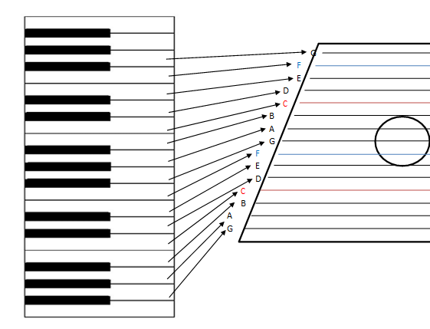
  - Use your electronic tuner and wrench to tune. If the note is too high, loosen the string. If the note is too low, tighten the string.
  - Use small movements! Unlike many modern instruments, this does not have geared tuners and the strings are short. Very small changes will make a big difference in the note. Too big of a movement and you risk breaking a string. It will take a lot of practice to get a feel for how much you need to move.
  - Have patience! A new instrument or an instrument that has not been played for a long time will take time to hold a tune. Expect to tune multiple times a day for a few weeks before it holds a tune. You will get faster with practice, so don’t give up!
  - Getting the hang of tuning is the most difficult part of playing this instrument. Don’t neglect tuning because a well-tuned psaltery will sound so good! It is worth the effort!
  - DO NOT USE PLIERS ON YOUR INSTRUMENT!
- How do I change the strings?
  - These typically use standard steel strings that can be purchased at most music stores. If you do not know the size of the strings required for your psaltery, I would recommend taking it to a local music shop. Most shops will be able to measure the diameter of your strings and tell you what you need.
  - There is some room to go either larger or smaller with your strings, but don’t go crazy. Typically, thinner strings will have more overtones for a richer sound. Thicker strings will have less overtones but a louder sound. If the strings are too thin, they will not stay in tune when plucked. If they are too thick, they may break, or you may damage your instrument. Also, thicker strings can be more uncomfortable if you are plucking with bare fingers. Remember, all things in moderation. It is okay to experiment and see what you like.
  - Different psalteries have different methods of stringing. Look at how the old strings are attached to your specific instrument before removing them so that you can put the new strings on in a similar fashion. It is very common for one physical string to be used for two “strings”/notes.
  - If your instrument uses zither pins or screws or something else that goes deeper into the wood as you tighten strings, make sure you unscrew them several turns before adding the new strings. This will keep your pins from going too deep into the wood to get the strings up to tune.
  - Make sure to keep your string windings neat.
  - It will take a lot of tuning and retuning before the new strings “settle” and hold a tune consistently. See above section on “tuning.” Don’t give up!
  - Video from TK O’Brien on how to change a lap harp string: https://vimeo.com/3370560
  - Video from Songbird Dulcimers on how to change a string. I personally like this method since it reduces the risk of your tuning pin sinking too deeply into the wood: https://youtu.be/O6eCrp9YyFA
- How do I hold this thing?
  - Western psalteries are more commonly held with the low strings thumb side
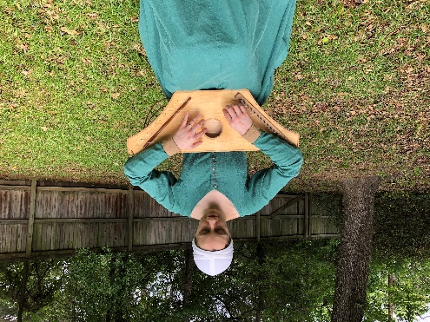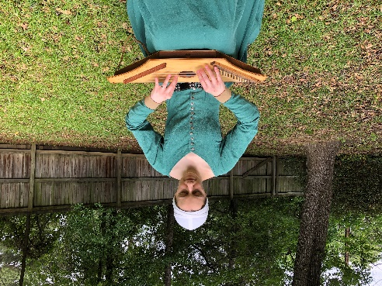
  - Baltic psalteries are more commonly held with the high strings thumb side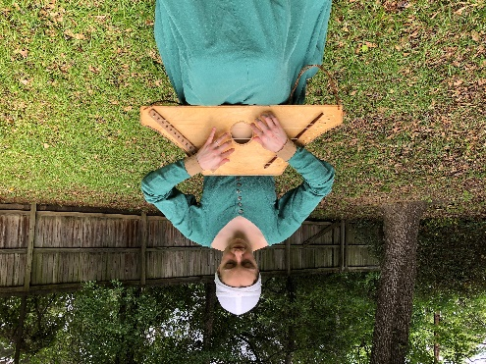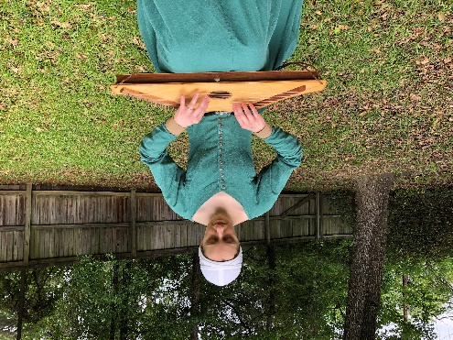
  - Easiest and appropriate to play lying flat on your lap. I recommend starting here.
  - You can angle on your lap (maybe better for the audience to hear)
  - Can support with your forearms (make sure you are not hurting your wrists!). This does not work with a lot of psaltery shapes. It is more difficult to play this way.
  - You can play with a strap.
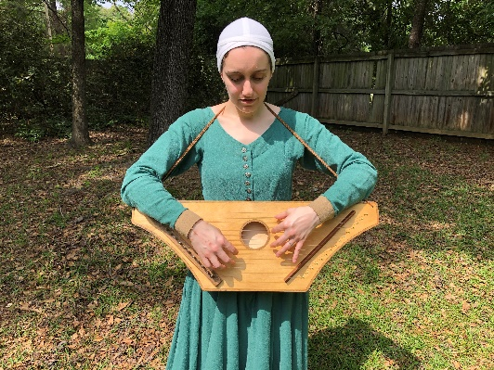
  - Cradle the instrument with your left arm and play with your right. This limits you to one hand for playing and is not seen commonly in historical artwork.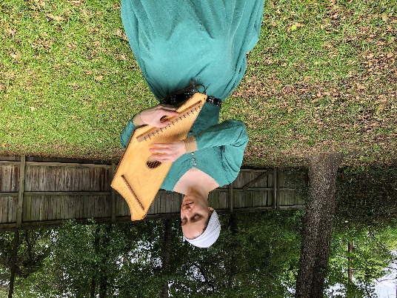
- How do I make a sound?
  - Picks/plectrum
    - Flat picks (good for strumming)
    - Feathers (period). Use one with a stiff quill, like goose feathers.
    - Finger picks. I recommend the Alaska Pik brand for your index, middle, and ring fingers and Fred Kelly Speed picks for your thumbs. The Speed thumb picks come in right and left hand options which is why I like them.
    - Just grow out your fingernails (period)
    - Use bare fingers (my favorite)
  - How do I pluck?
    - Try to keep your wrists straight. Nothing should hurt. If it starts hurting, you are doing it wrong!
    - I use my thumb, index, middle, and ring fingers. Pinky is less common.
    - Use the bottom edge of your thumb rather than the tip. Pull the thumb toward the other fingers.
    - Use more of the tips of your other fingers and pull toward the thumb. You can optionally push on the string so that your finger lands on the next lower string.
    - If you play one note multiple times, alternate between multiple fingers.
- What songs can I play?
  - The psaltery is diatonic. Compared to a piano, it only has the white notes. Some tunes will be impossible to play. You can retune to play in different keys, but it is not possible to change keys or play notes outside the key during the middle of a song.
  - The range is typically only two octaves. This usually allows for a simple melody and limited accompaniment.
  - Medieval instruments are generally limited by today’s standards. But it can be fun to work within the limits of your instrument rather than being frustrated by them. This also can allow for more historically accurate music.
- How do I learn a song?
  - By ear
  - From music
  - From specially made song sheets (you can make your own!)
  - From numbers
  - With so many strings, it is easy to get disoriented. I often put small red sticker dots under the C notes and small blue sticker dots under the F notes. This mimics the colored strings on most modern harps while not being too visually obtrusive.
  - You can make a strip of paper to slide under the strings where you label each note. However, this can easily become a crutch, so I do not recommend it.
- How to add “medieval” harmonies
  - Find the “tonic” of your melody. This is often (but not always) the first note and the last note of a song.
  - Intervals are the distance between notes/strings in a diatonic scale. So a 5th above C is G. That is C(1), D(2), E(3), F(4), G(5). Intervals are easy on the psaltery because you only have a diatonic scale. The interval will be the distance between your strings including the string you start on and the string you end on.
  - 3rds were less common and generally sound more modern.
  - Octaves (interval 8) and 5ths are best for medieval music. 4ths are also acceptable and often required given the limited range of your instrument.
  - Simplest is to add a drone note on the tonic or the 5th above.
  - Add a chord to your drone by adding the octave or the 5th (which may end up being a 4th)
  - You can use a single note or two note chords to add rhythm.
  - Alternate between the 5th and octave.
  - If your melody is in the upper end of the instrument, you can add a repeated broken chord pattern using octaves and 5ths.
  - You can vary the picking pattern and rhythm of your broken chords for different variations.
- How to improvise “medieval” music
  - Often medieval songs are in different modes than we are used to. Dorian mode is very common. You can improvise a “medieval” sounding tune by starting on D and ending on D. Listen/play a lot of authentic medieval tunes and this will become more natural.
  - Add some of the accompaniment techniques already covered.
- Psaltery is also good for vocal accompaniment or to accompany story telling. Some of the simple accompaniments listed above can be added strategically to a story to add drama, suspense, and emotion. This takes quite a bit of practice. It can also be fun to improvise accompaniment for other people who are telling stories.

My contact info:
Email: elizabethbkrause@gmail.com
Facebook: https://www.facebook.com/eannebrowning/
YouTube: https://www.youtube.com/channel/UCEQrROr_pDOEWFM6FlD4P1g

