Book of Pictures
Leabhar na Léaráidí

Siobhán an Einigh of Connacht
Kingdom A&S 2017

Contents:
1 Y Gododdin/Welsh Epic Poem p3
2 Garb – Leine p6
3 Garb – Ionar p11
4 Garb – Brat p15
5 Garb – Footwear p18
6 Polairie Leather bag p21
7 Quick Mead p27

1 Y Gododdin – Welsh Epic Poem

1A: Book of Aneirin/Llyfr Aneirin – 13th Century text for the 6th Century poem Y Gododdin
All Images from the National Library of Wales Book of Aneirin online
https://www.llgc.org.uk/index.php?id=6493
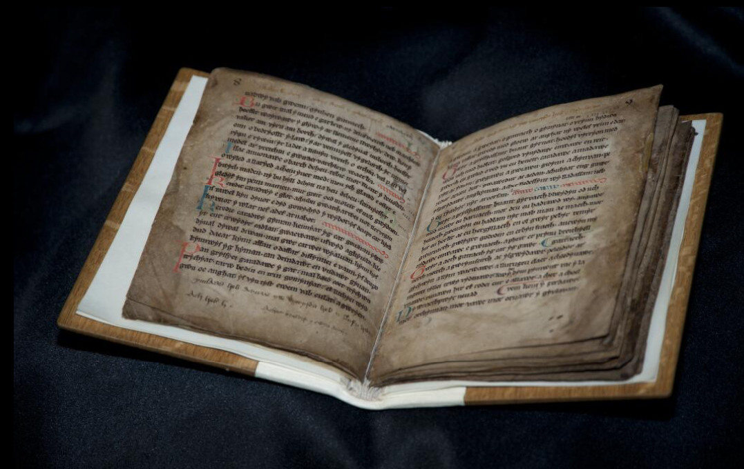

1B: Page 18-19 of the Book of Aneirin/Llyfr Aneirin
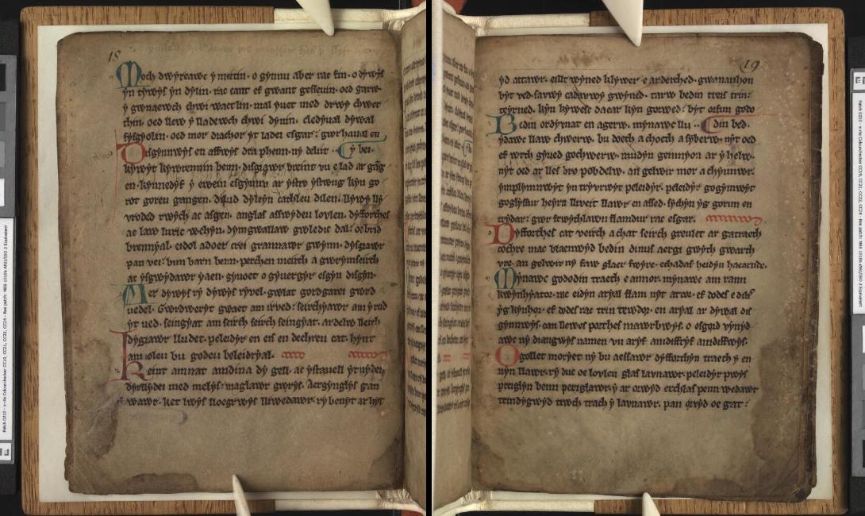

1C: Verse LXXVIII from page 19 above, my favourite, on the Welsh king Mynyddawg.

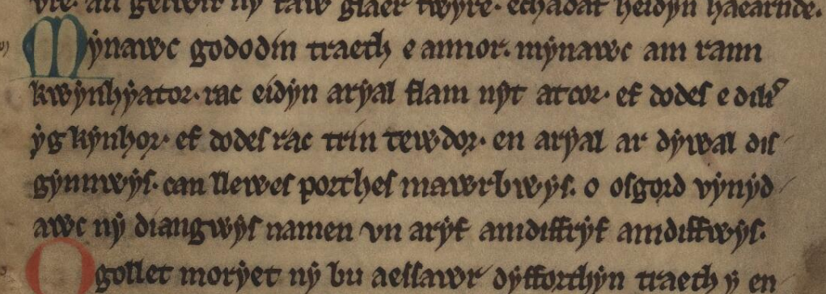

2 Garb – Leine
2A Senchus Mór facsimile – Brehon Law Academy |  |  |  | 2B Basic materials for leine
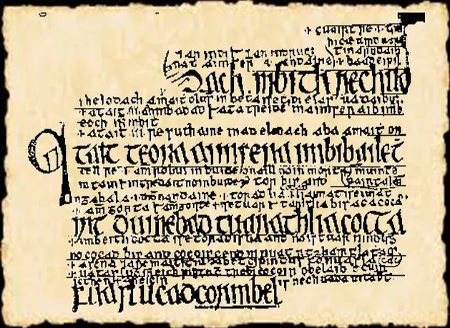 |  |  |  | 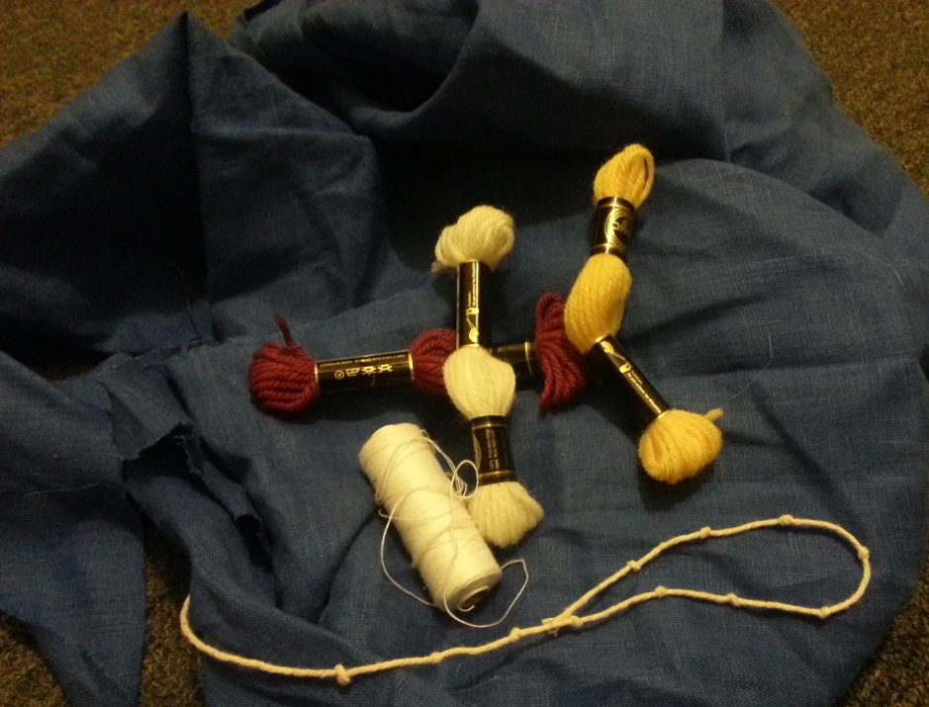
2C Mary in lavendar leine, maroon brat, and blue ionar - Book of the Kells page 7v  http://digitalcollections.tcd.ie/  home/index.php?DRIS_ID=MS58_003v | 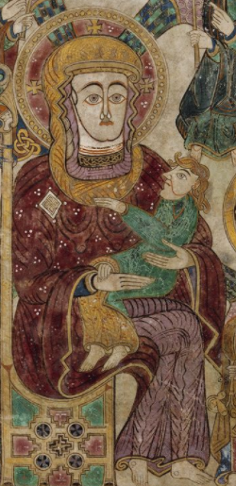 |  |  | 2D Cross of Muiredach, west side. http://ireland.wlu.edu/cross/Muiredach/west/2.htm
 |  |  |  | 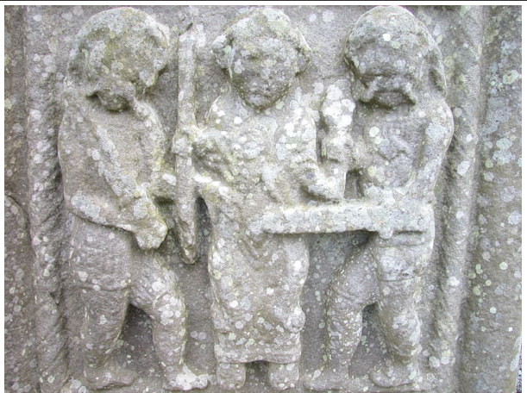
2E The leine  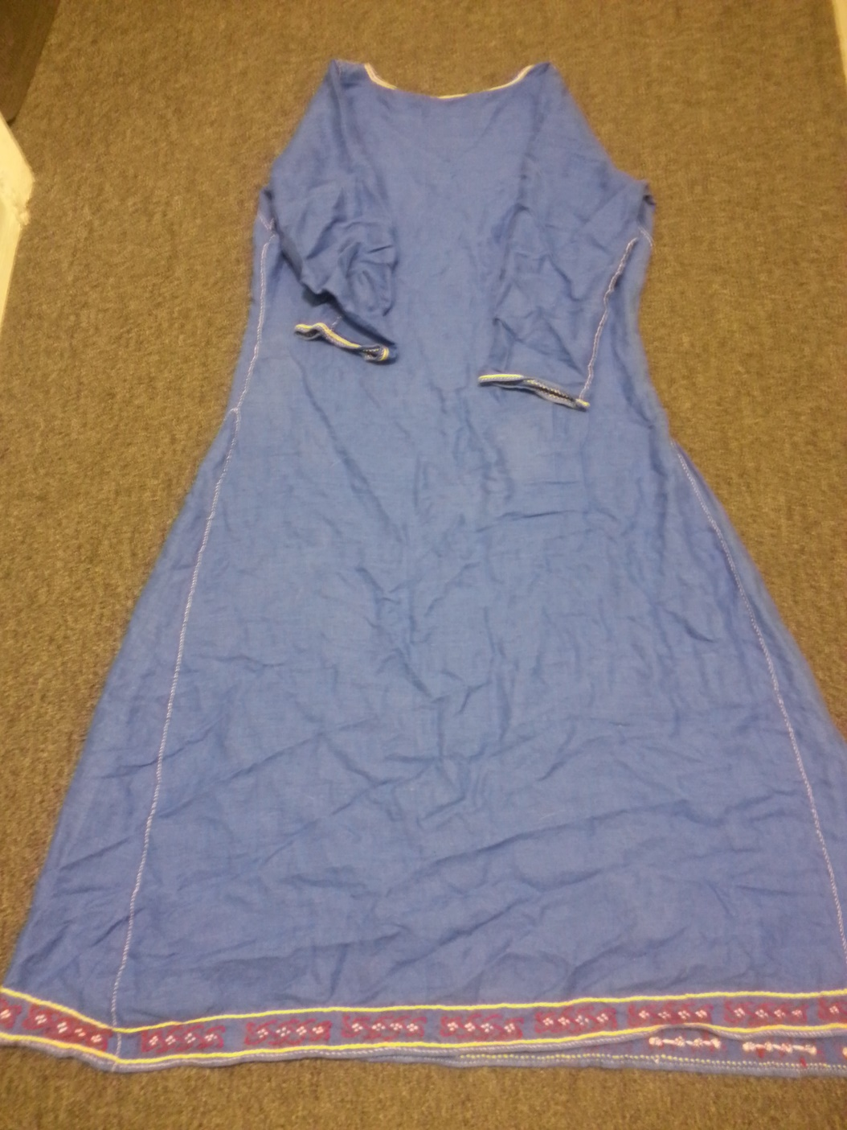 |  |  | 2F Measuring rope  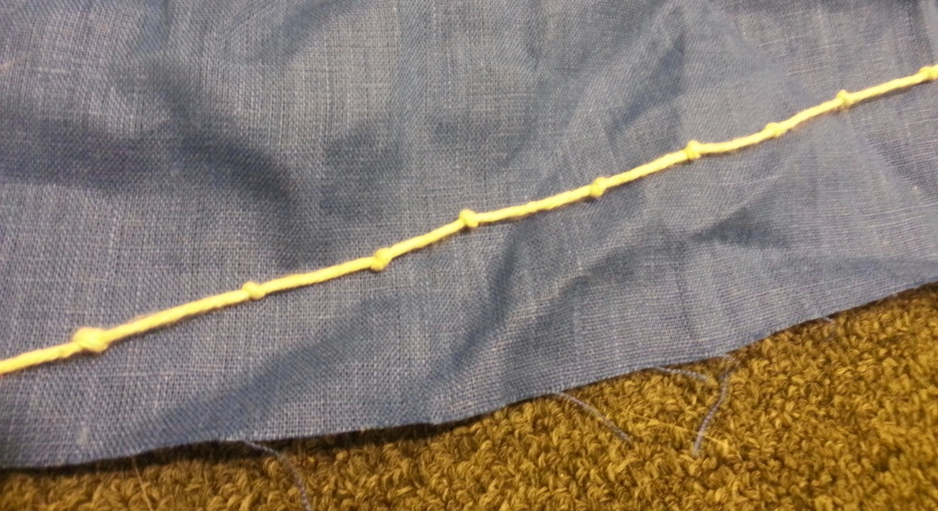
2G Cloth pattern for sleeves  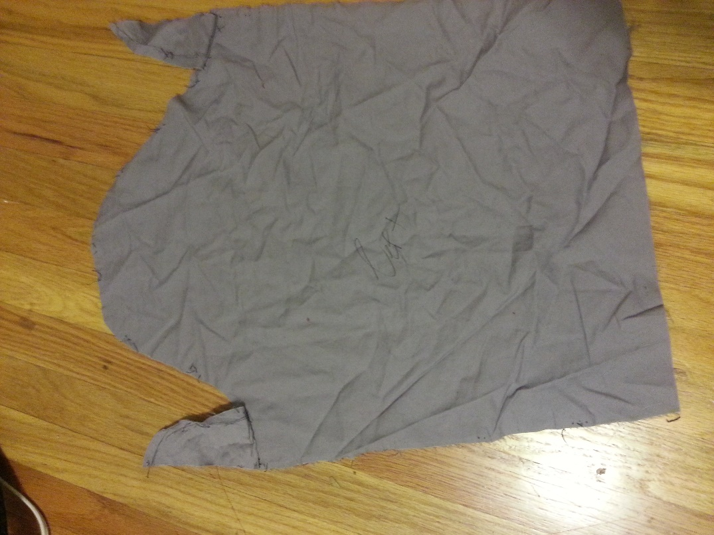 |  |  | 2H Period sleeves vs my sleeves. Period would have a straight edge, mine are more curved and modern.  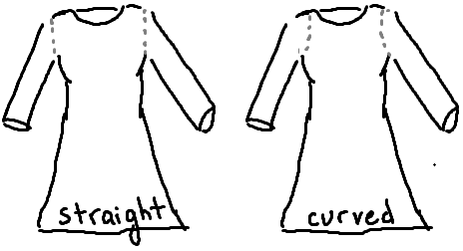
2I Period stitches – Rolled hem (p18) , running and rolled seam (p7), and embroidery split stitch (p21) Baker, 2009  http://nvg.org.au/documents/other/stitches.pdf |  | 2J Rolled and running seam stitch
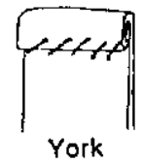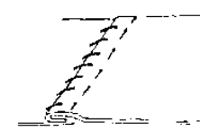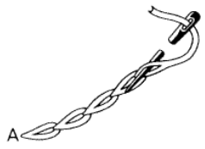

2K Book of Kells design full page 1r, inspriation for the embroidery  http://digitalcollections.tcd.ie/home/index.php?DRIS_ID=MS58_003v |  | 2L Book of the Kells p 1r embroidery inspiration, up close and rotated.  http://digitalcollections.tcd.ie/home/index.php?DRIS_ID=MS58_003v
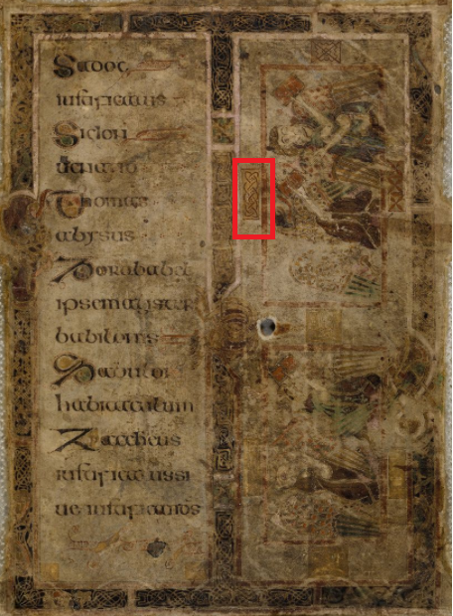 |  | 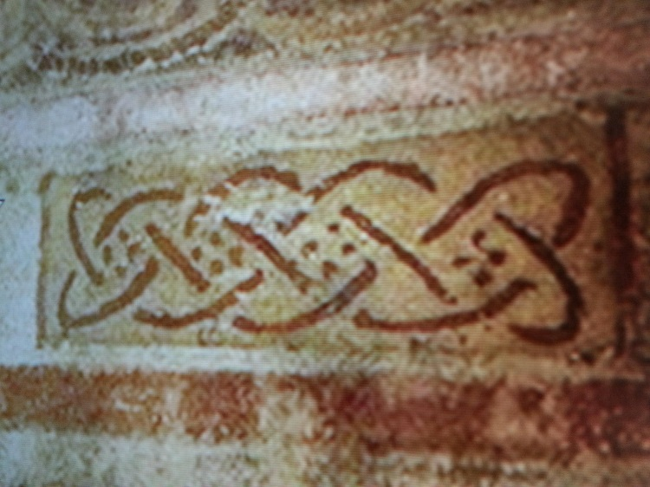

2M Embroidery using a split stitch based off of p 1r design | 2N Embroidery using a split stitch based off of p 1r design
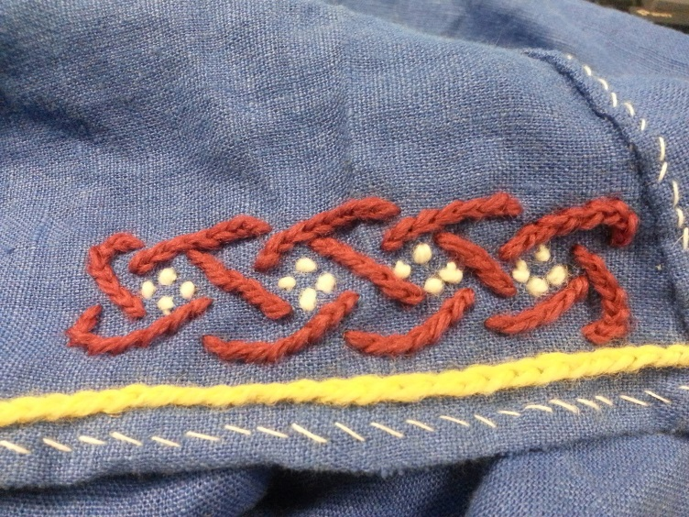 | 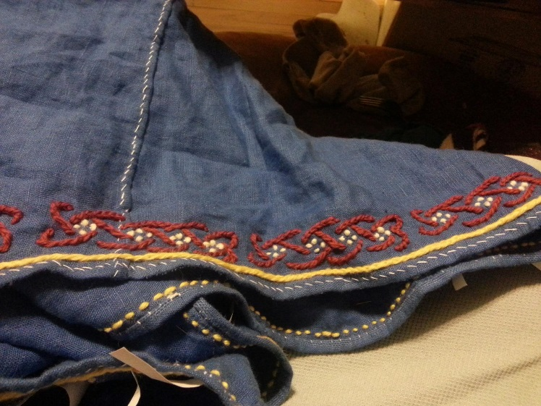

3 Garb – Ionar

3A My Ionar | 3B Fabric, needles, thread
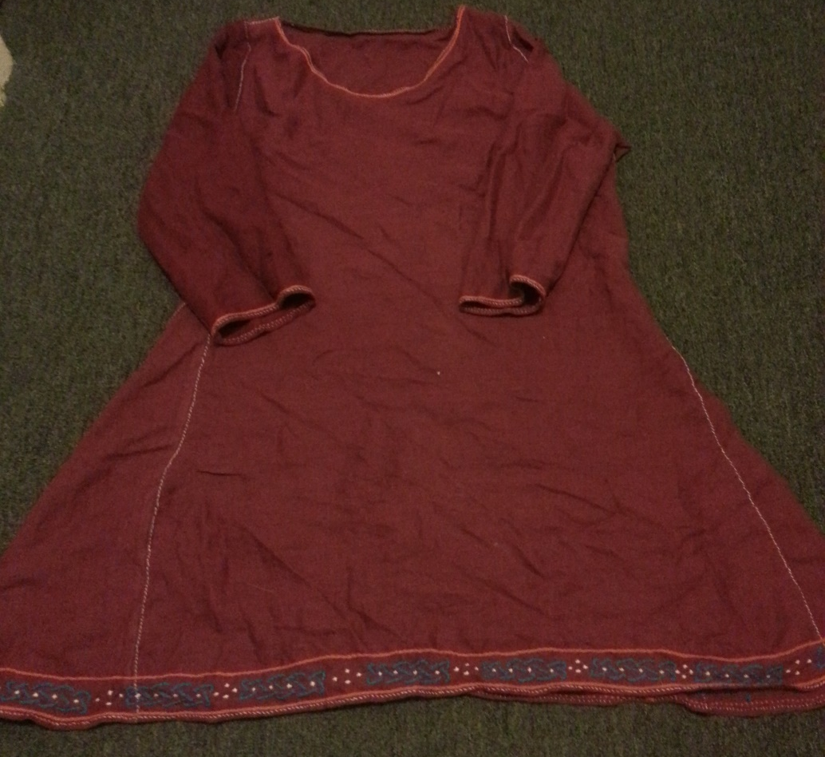 | 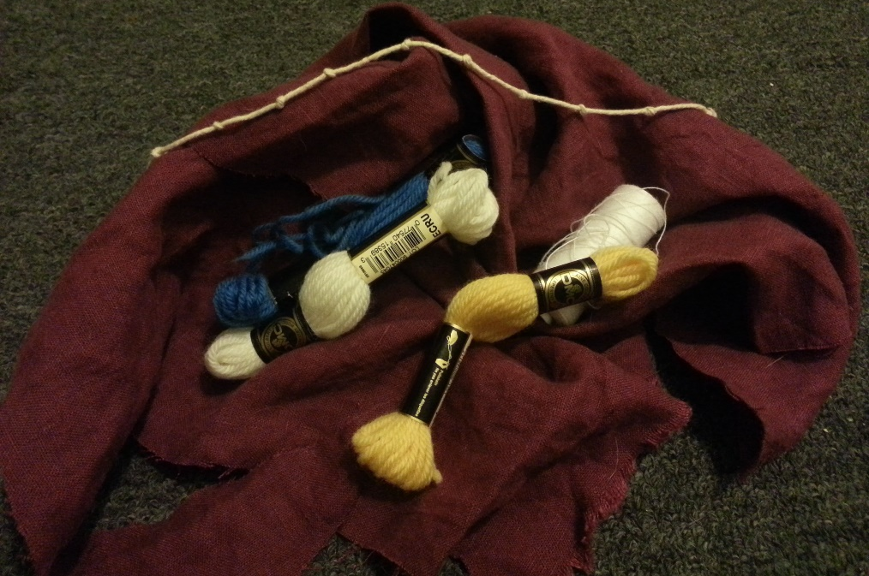

3C Mary, Book of the Kells, p7v. The leine is a lavender-purple, the brat is a rose red. There is no evidence that sleeves were made different colours than the body, so there’s a good chance the blue sleeve peeking out from the brat is a different layer, a ionar. | 3D John book of the Kells p 291v. Similar to Mary, the leine is one colour, the brat a second, and the sleeves a third of a ionar.
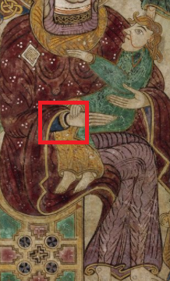 | 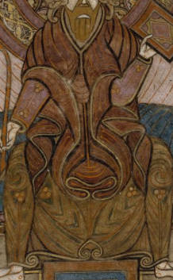
3E Unnamed figure p 3v. Here we clearly see two layers of garments at the neck – a leine of red-brown and an ionar of a lighter shade, the ionar neck bounded by embroidery. | 3F Unnamed figure p29r. This garment shows the two different layers of decorated ionar and leine, with the leine sleeves showing through the brown brat.
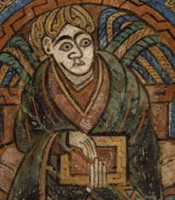 | 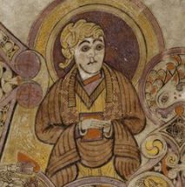
3G embroidery closeup  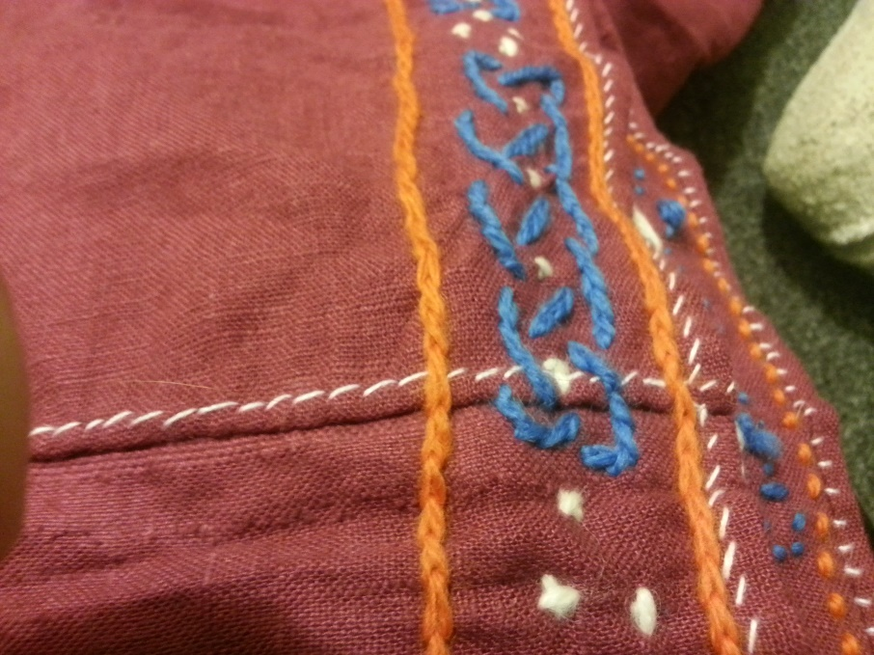 | 3H Full garb  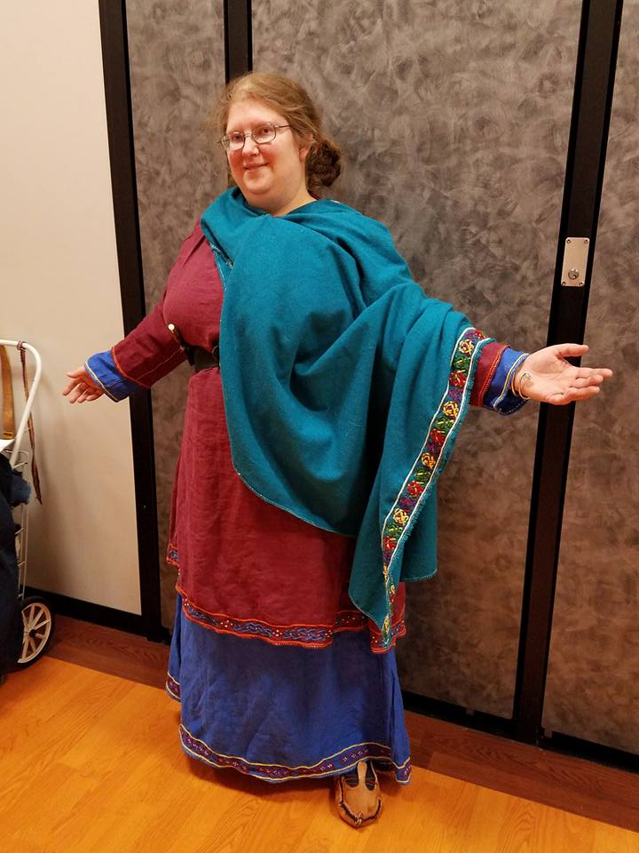

3I County Derry buckle  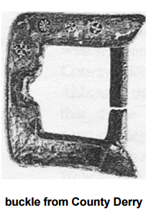 | 3J Buckle styles in-period. Many were found with scraps of leather or woven belt still attached, but no full belts have been found at this time. Youngs, Susan 1997
 | 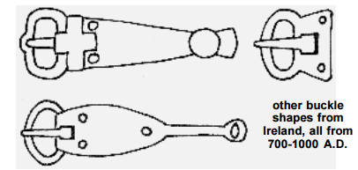
3K My belt
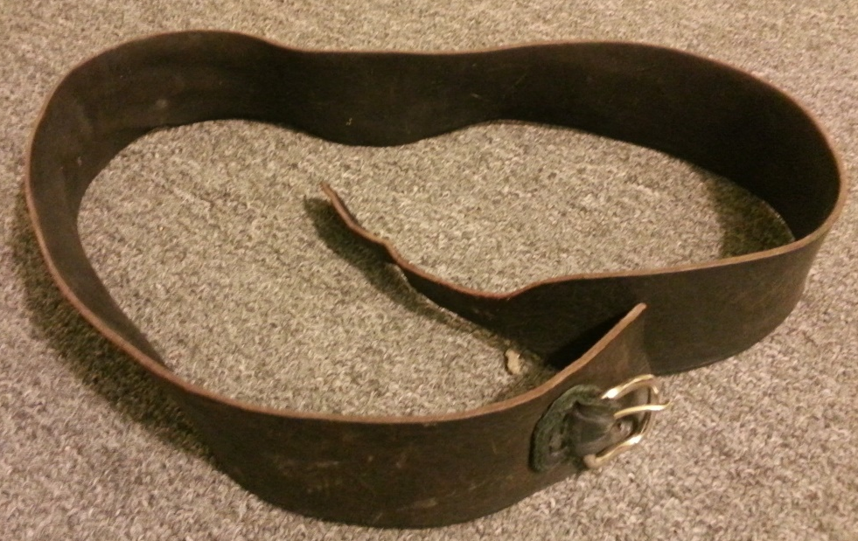

4 Garb – Brat
4A Brat full laid out | 4B Brat pinned/folded
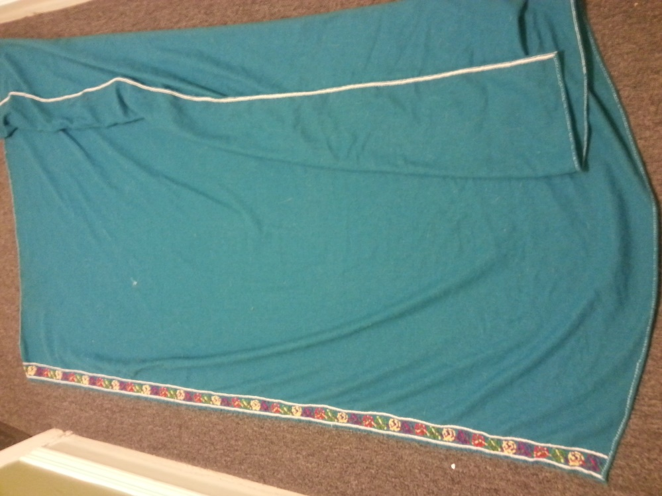 | 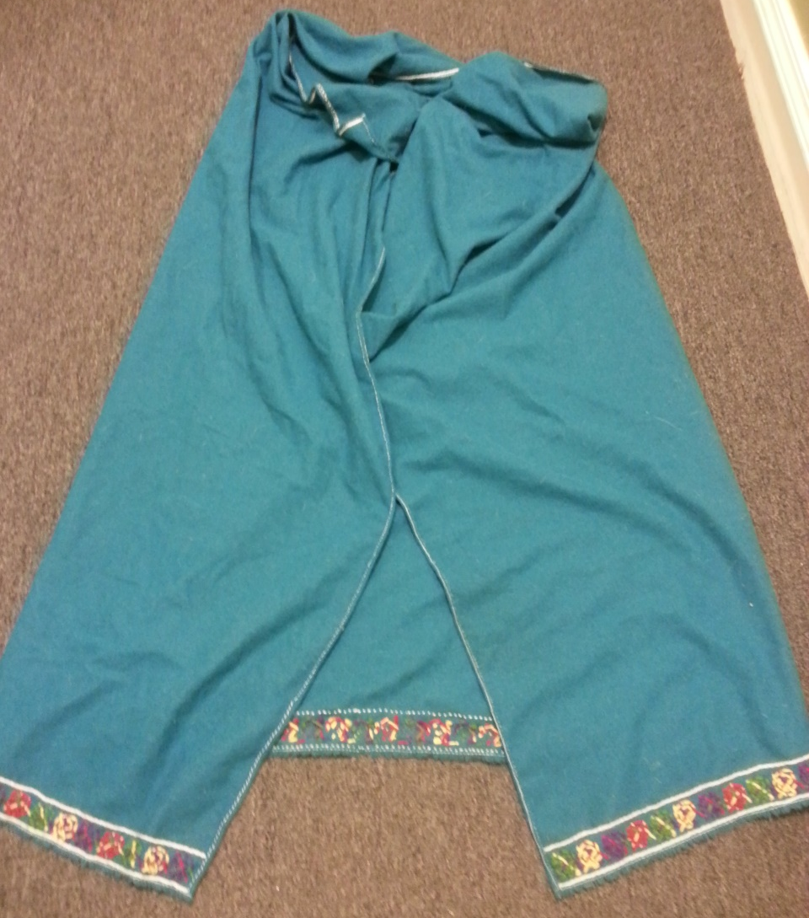
4C Book of Kells p32v – inspiration for the brat embroidery
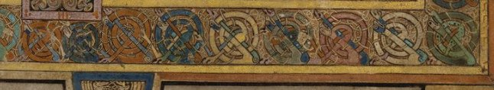
4D Embroidery outline
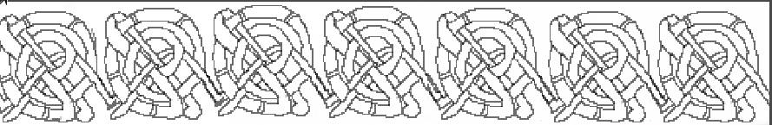
4E Planned colours
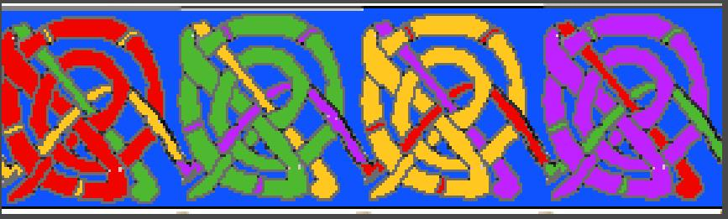
4F Embroidery in process
4G Embroidery spirals done, just need top bounding stitches
4H Finished embroidery
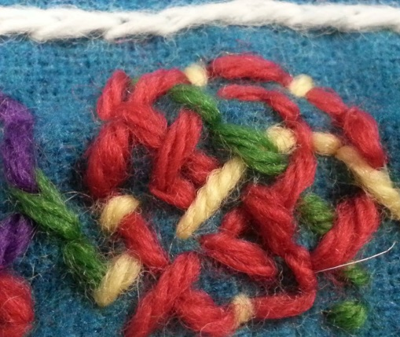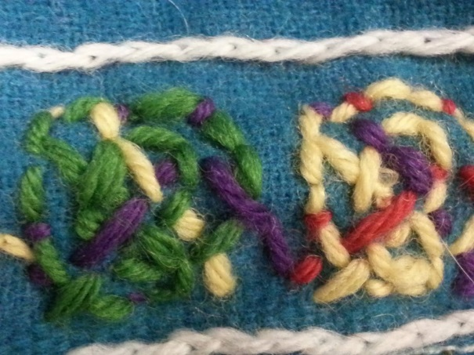
4I Finished embroidery – 70 inches
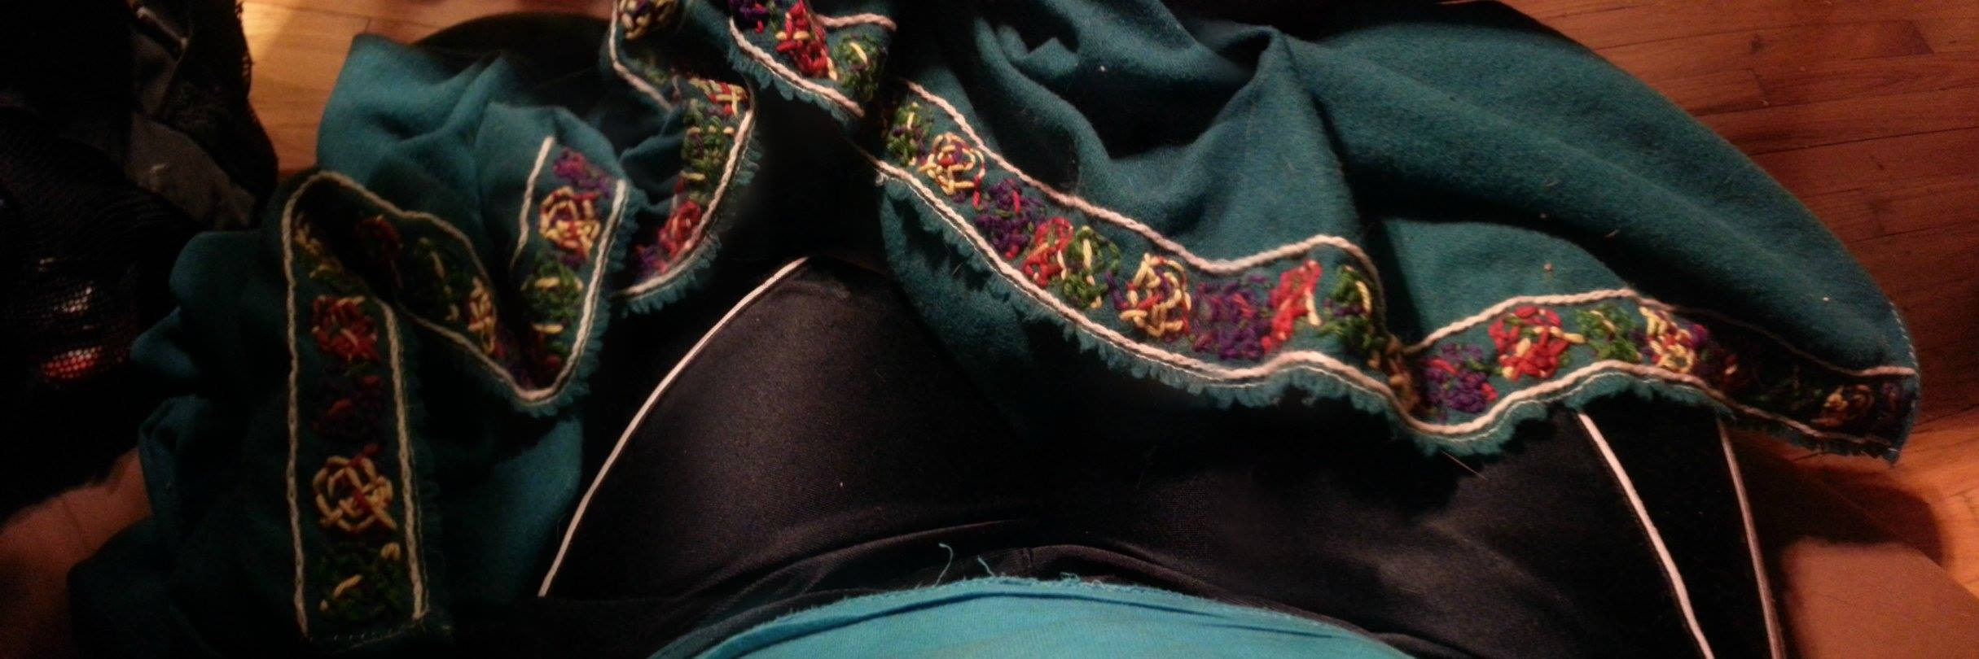
5 Garb – Footwear
5A Finished shoes  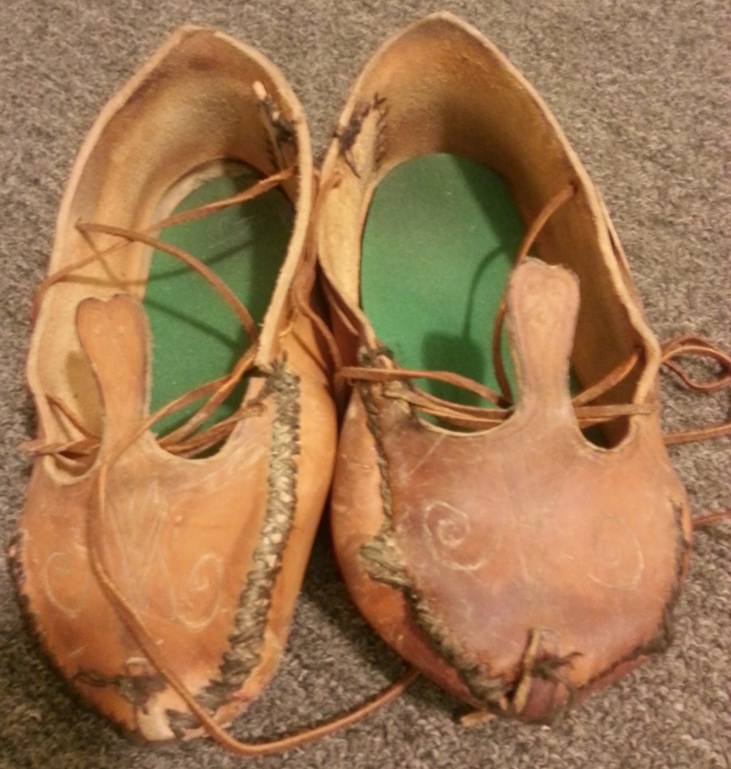 | 5B, Lucas Type 1 shoe pattern  http://www.texascoritani.com/articles/footwearinireland/
 | 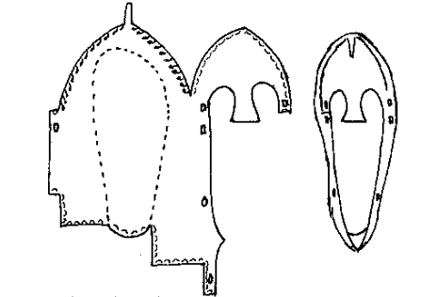
5 C Period Lucas Type 1 bog shoe  https://paleotool.com/2013/12/06/irish-brogues-and-other-simple-shoes/  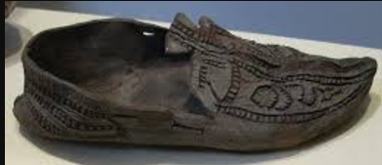 | 5D My shoe cut out  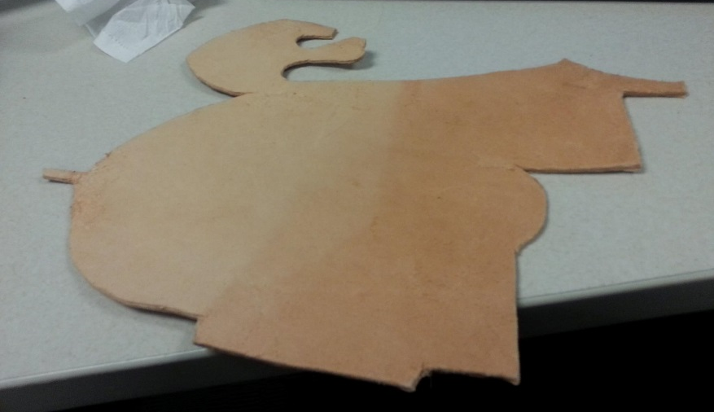

5E Shoe being sewn. The leather was first tooled using an awl and plastic letter opener – in period this would have been done with horn. | 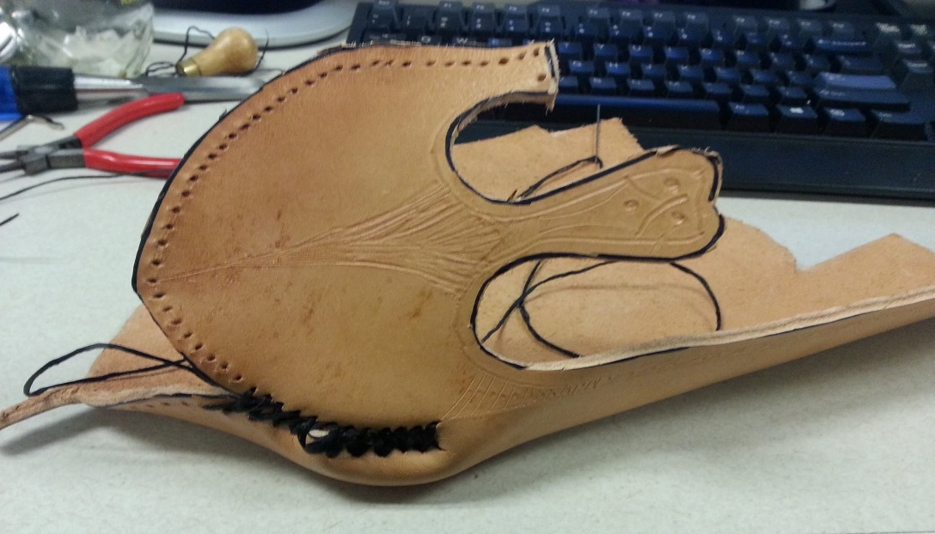
5F The final shoe was rubbed with beeswax to help protect it.
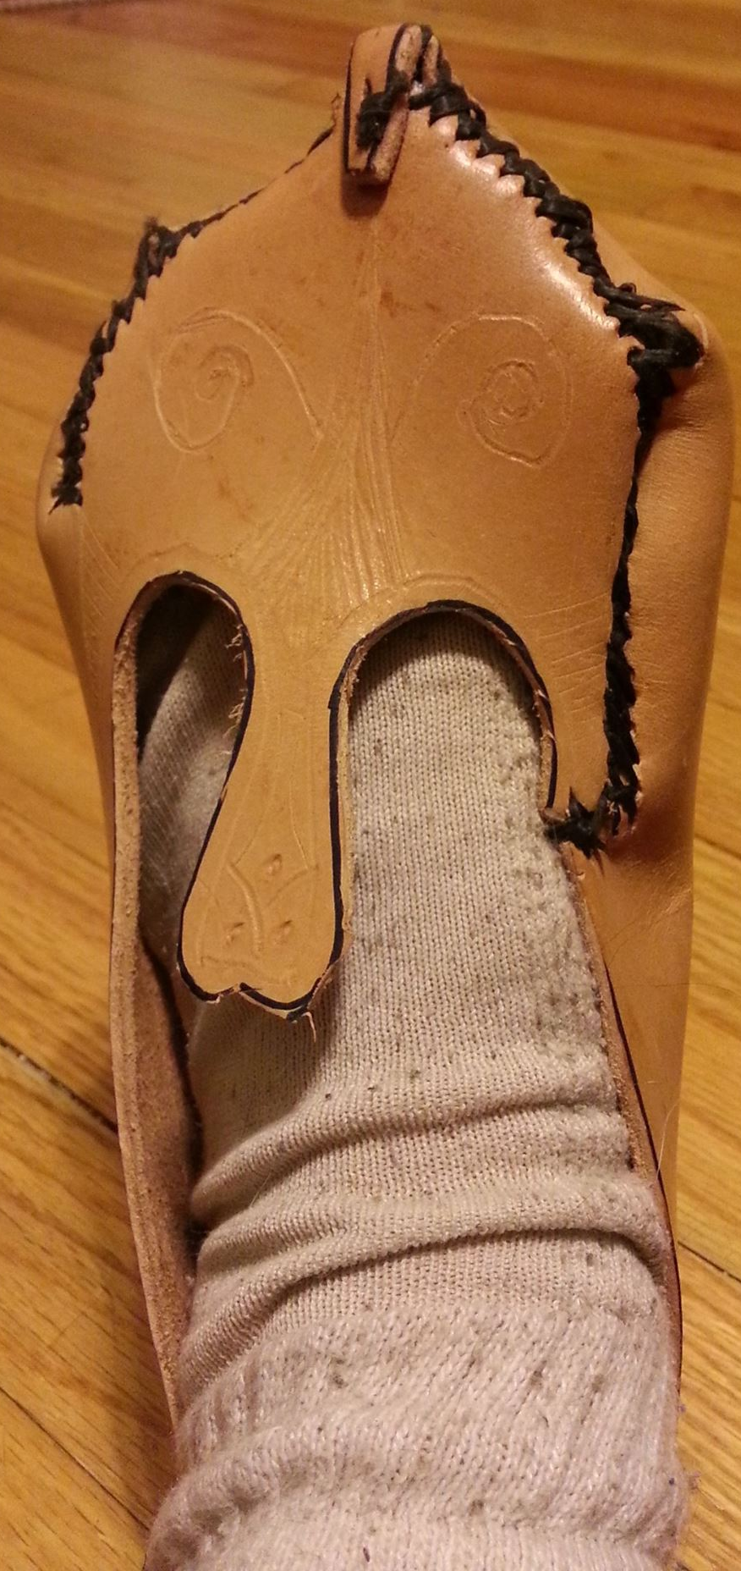

5H Coppergate socks | 5G Naalbound sock – the sock had not felted itself yet at this point.
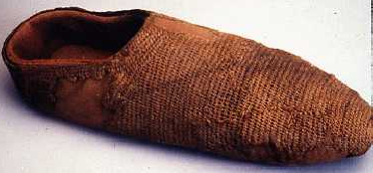
5I Naalbinding materials – not pictured, my thumb
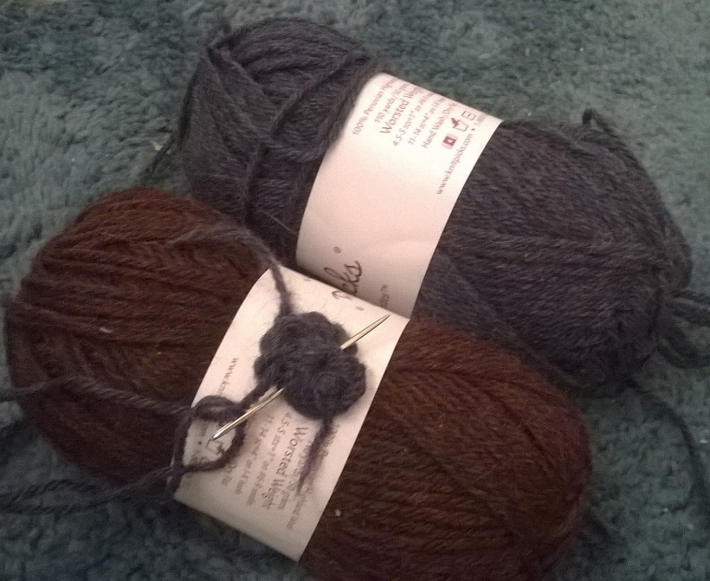
6 Polairie leather book satchel
6A Polairie in hand period example 8th c  Treasures of Irish Art, 1500 B.C.-1500 A.D. Ed. Lee Boltin. New York: Metropolitan Museum of Art & Knopf, 1977. 86. Print. | 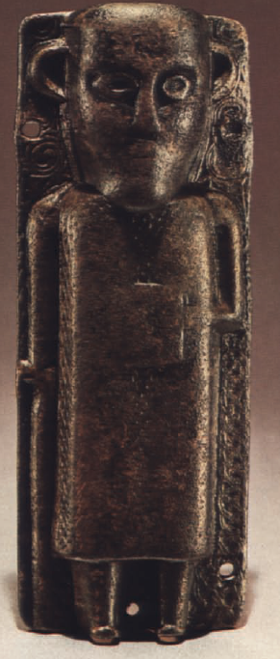
6B Armach polairie - Trinity College Dublin, Broderick, 2014 | 6C Corpus Christi polairie - Aidan, 2006
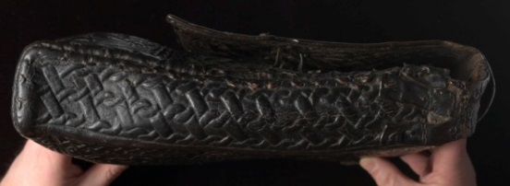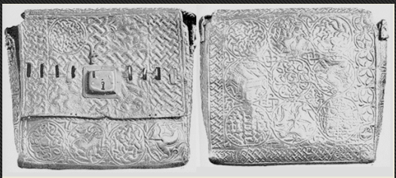 | 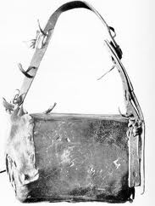
6D Breac Modac budget - Aidan, 2006 | Loch Glashan Crannog satchel - Broderick, 2014
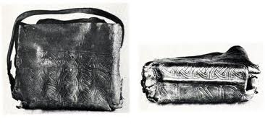 | 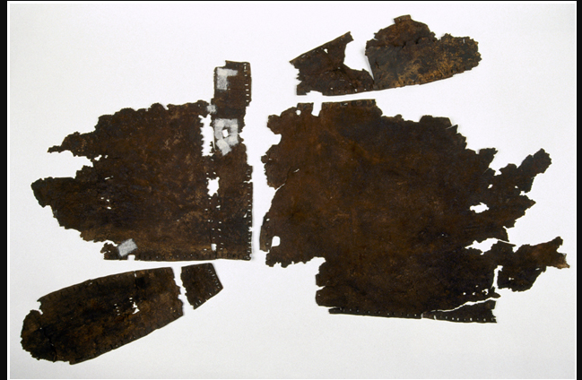
6F Waterer pattern of Breac Modach budget - Waterer, p 77 | 6G my pattern
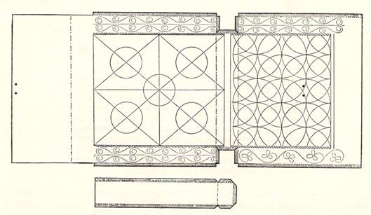 | 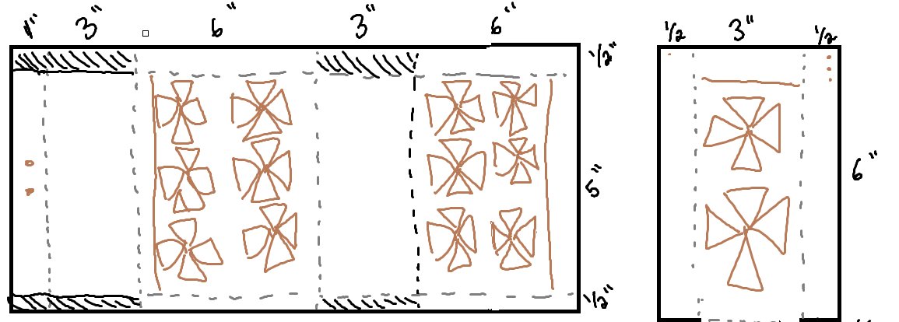
6H Blank leather, in the process of being cut | 6I Tooling the leather - gusset
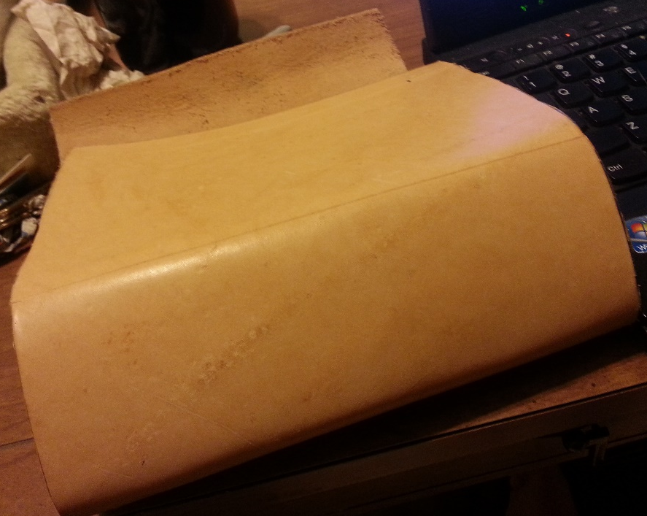 | 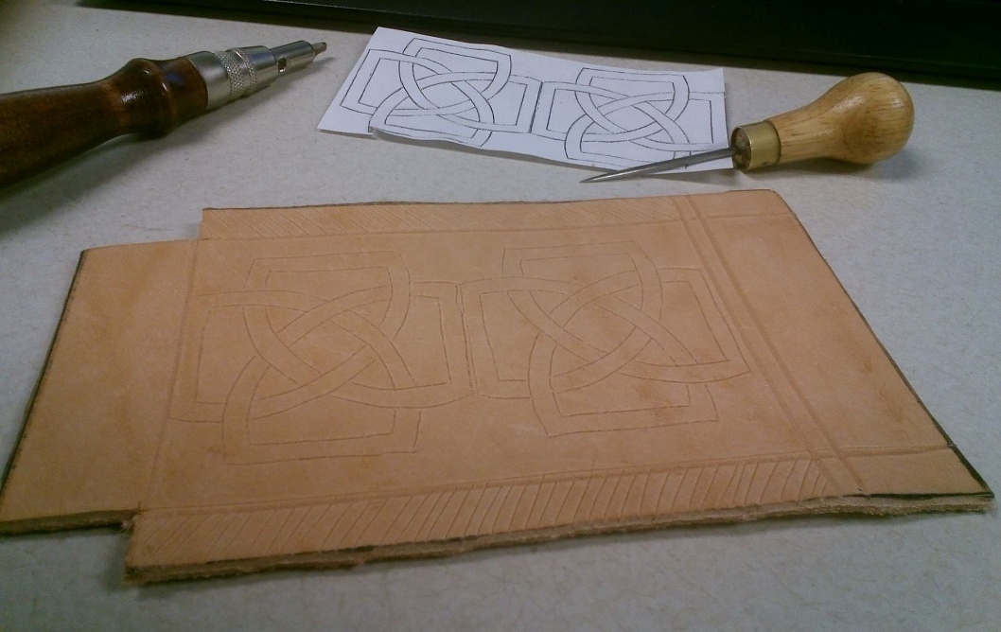

6J Tooling the leather – main bag | 6L Stitching on bag – Waterer, p 78, 1968
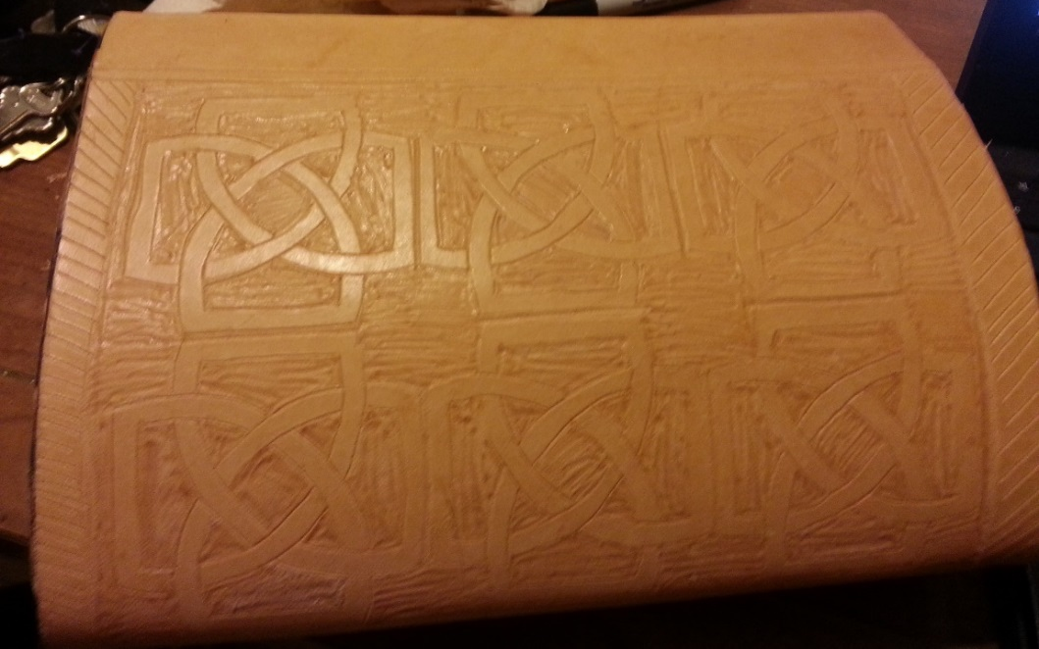 | 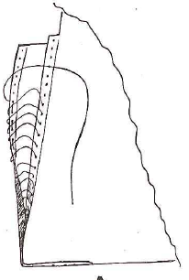
6K – Tooling the leather – all three pieces
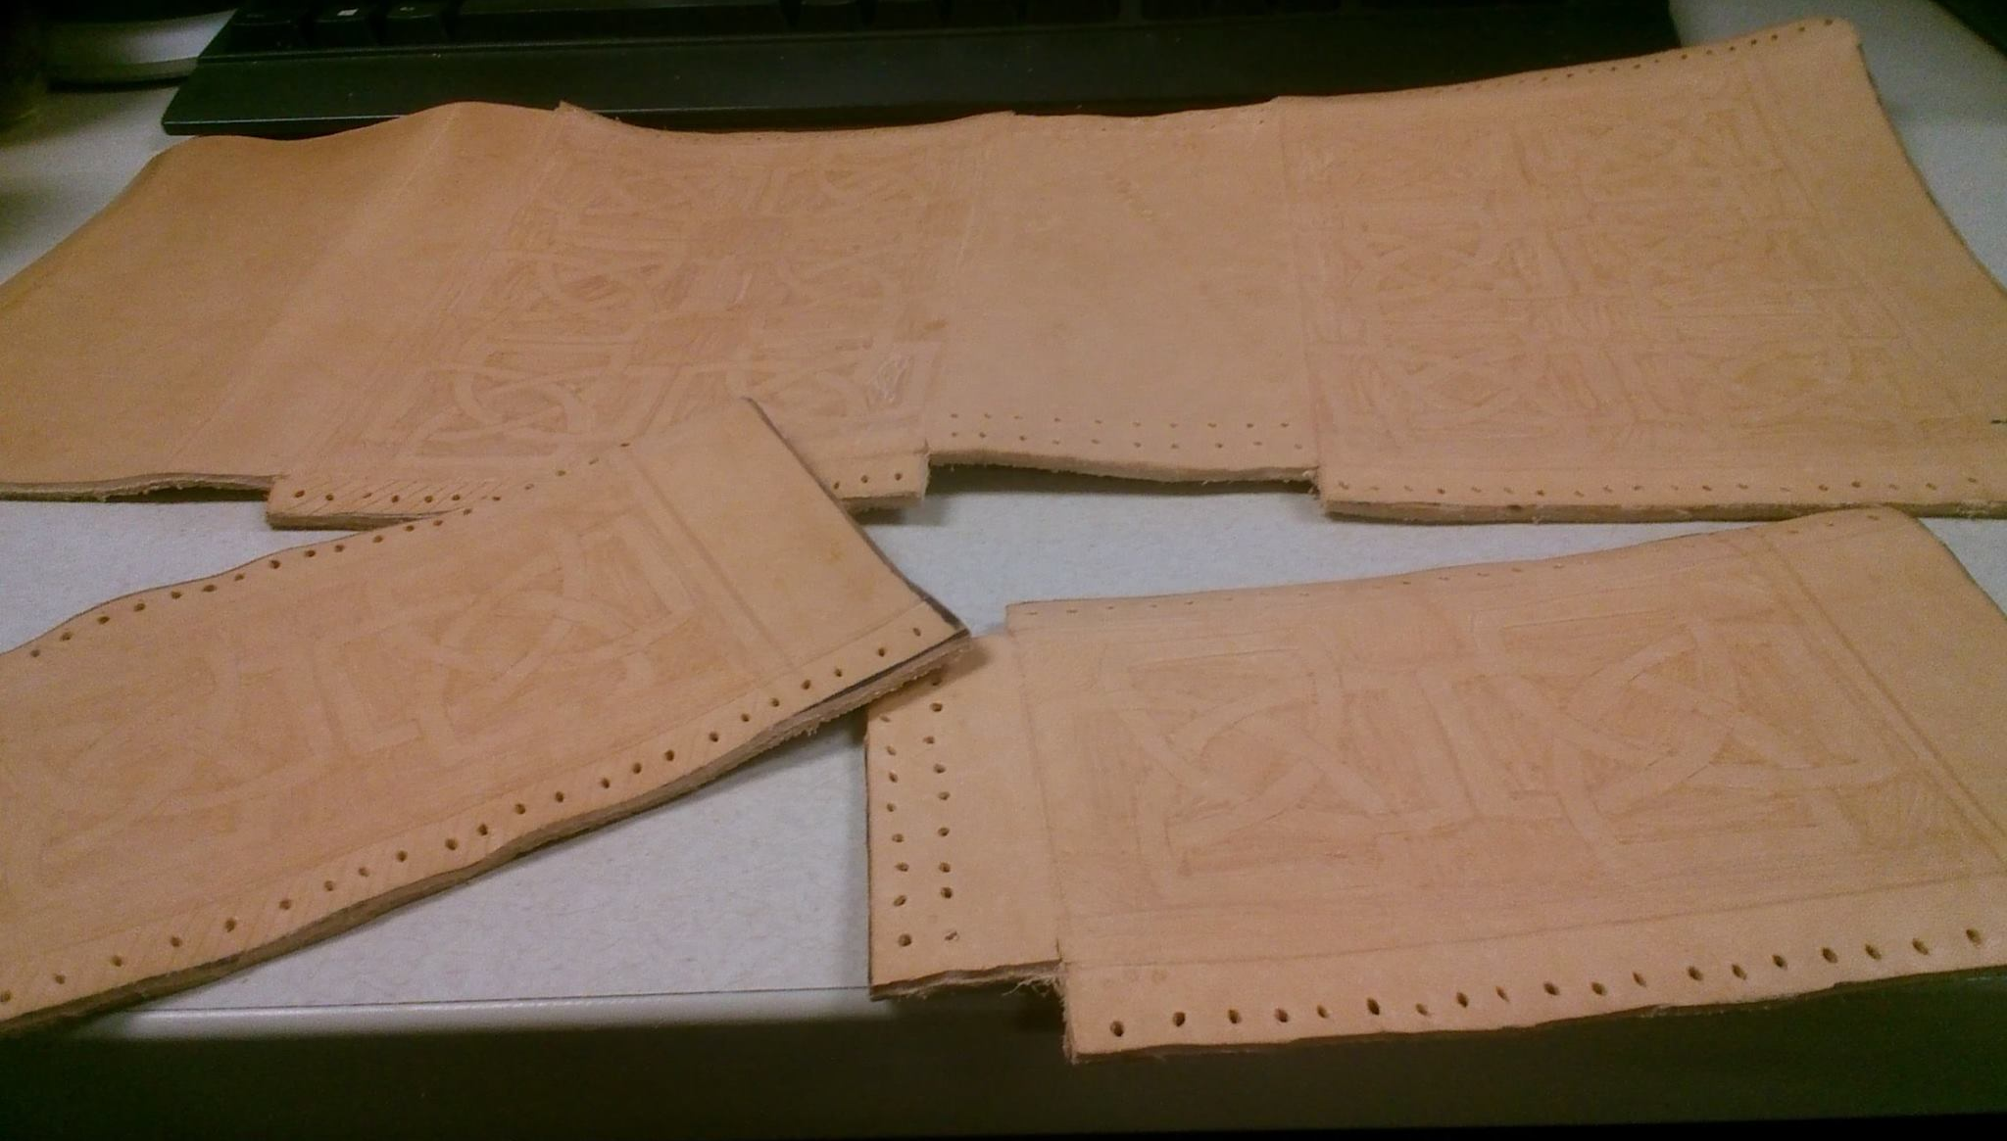

6M – Bag rubbed down with beeswax and heated
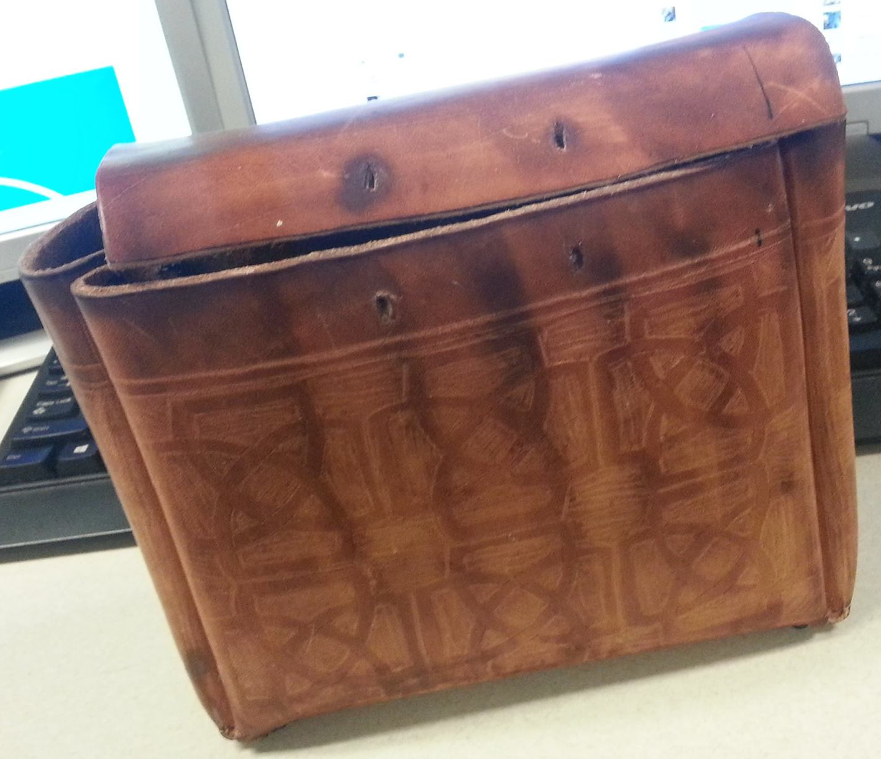 | 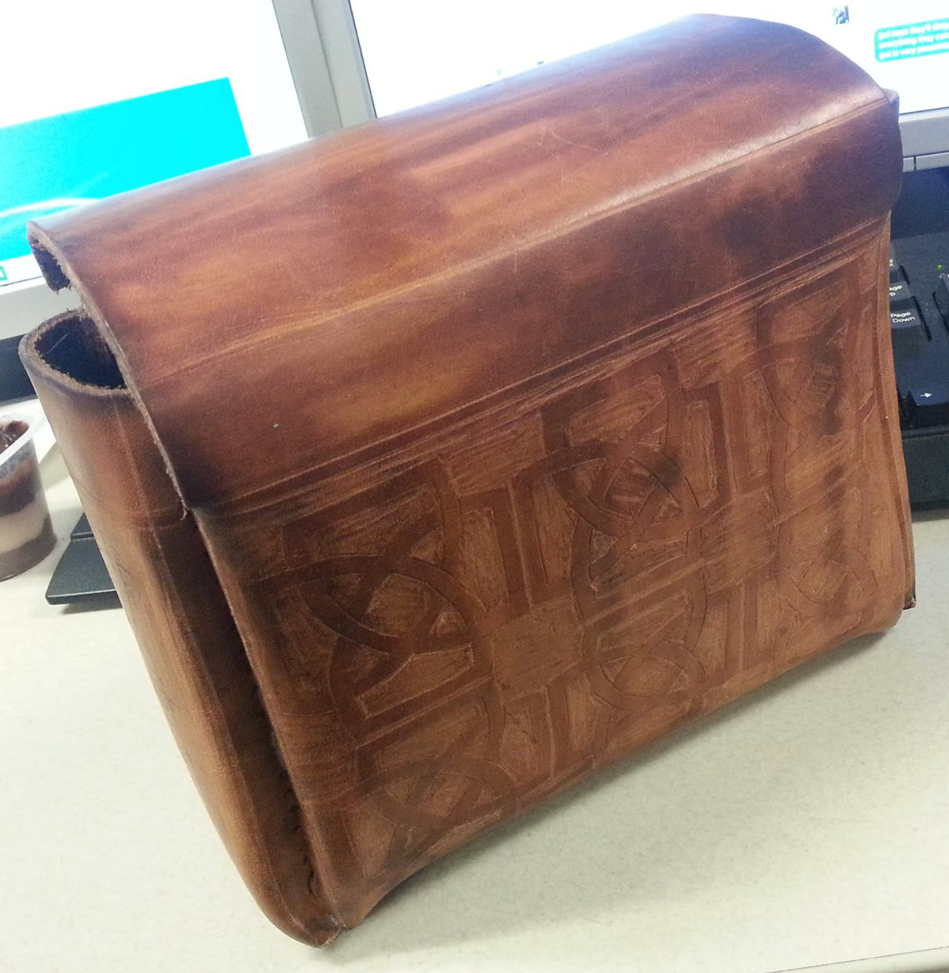
6N Bag with strap | 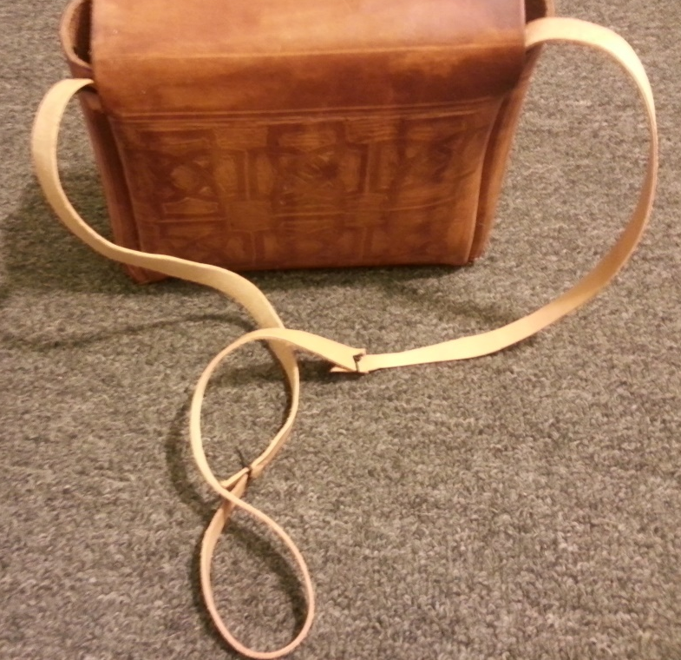

7 Quickmead

7A Mead wort cooking on stove | 7B Ale yeast used
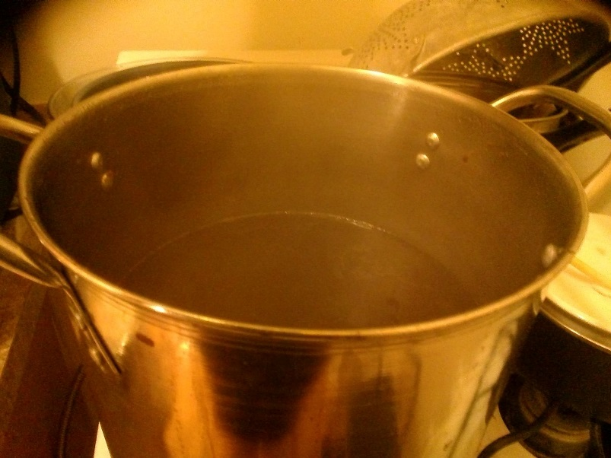
7C Pot with sterilization liquid and small items – airlock, thermometer, etc
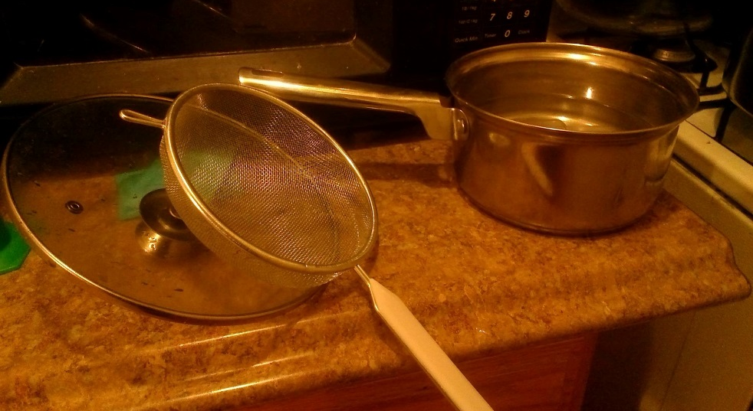
7D Mead fermentation | 7E Up close fermentation
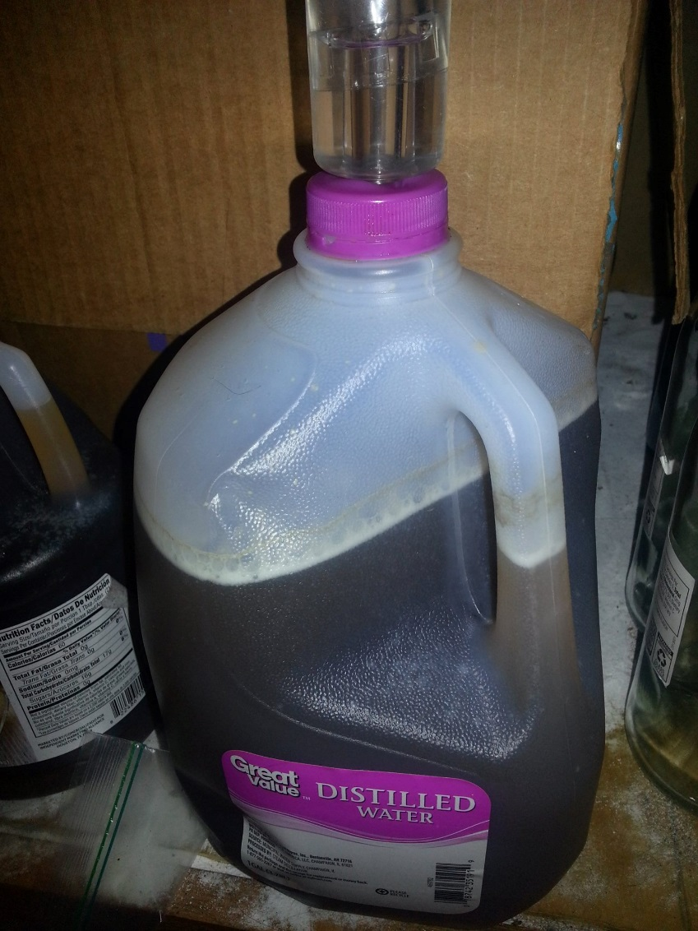 | 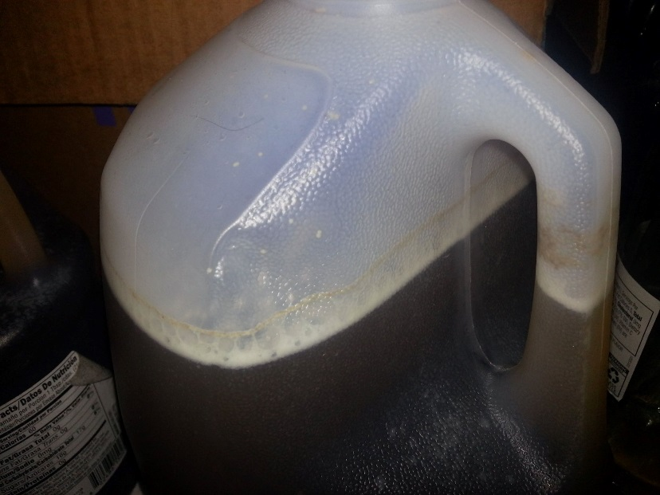
7F All 4 bottles of mead | 